Hartburn Primary School
Early Years Admissions 2019-2020

Nursery Admissions

We have a 39 place nursery. Children attend either a morning or afternoon session.
There are 3 full time staff and 2 part time staff.

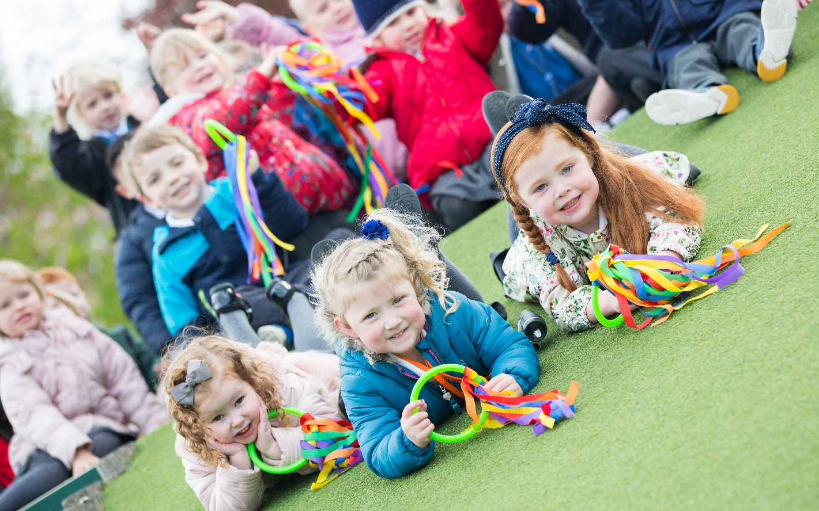

Most of our children come from either Hartburn or the surrounding local areas in Stockton on Tees. Many of our children know other children from having attended the same pre-school or day-care nursery, but even if children arrive here not knowing anybody; we find that they all settle in and make new friends very quickly.
Soon after the Easter holidays, office staff will begin contacting parents/carers by letter offering them a place in Nursery for their child. Children must be 3 years old before they qualify for a nursery place. We have a long waiting list so we are not able to guarantee places will be available for all children as soon as they reach three years old. Parents will be asked to express a preference for either a morning or afternoon place. However, we are not able to accommodate all requests.
Please note that a place in Nursery does not guarantee a place in school.
(Local Authority Admission Policy)

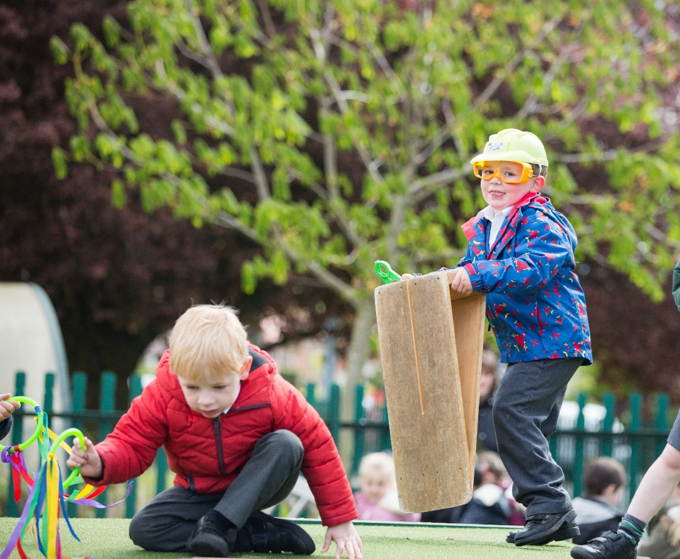

Nursery Hours
- Morning Nursery hours are from 8.45am – 11.45 am
- Afternoon Nursery hours are from 12.30pm – 3.30pm

Parents are welcome to visit the school before they accept a place but most people accept by return of post, as we are a popular school. Parents will then be sent a letter confirming either a morning or afternoon place and inviting them to attend a meeting in July.

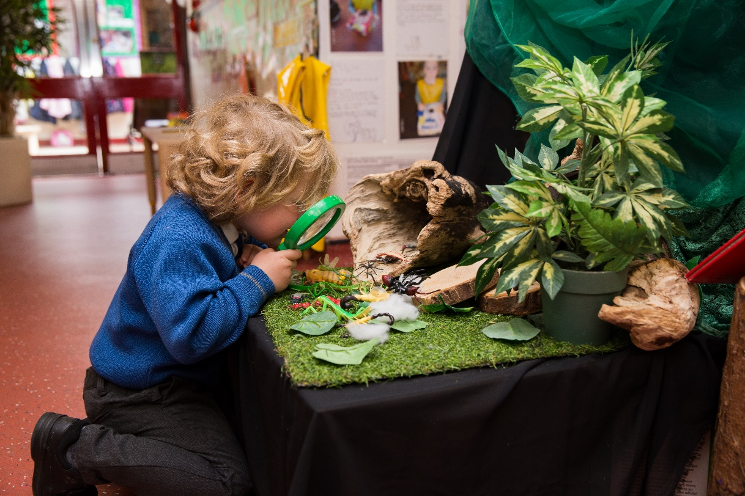

Starting Nursery Information Meeting

In the summer term, an information evening is held for parents and carers who have accepted a place for their child in nursery for the next academic year. This gives them the opportunity to meet the Early Years staff, the Head Teacher and local companies who supply school uniforms.
At the meeting parents receive an Education Information Pack about EY (Early Years) at Hartburn Primary School and will have the opportunity to look around school and spend some time in the Early Years environments both indoors and outdoors.

Parents will also be given written notice of 3 really important dates.
A date when EY staff will come and visit children in their own home. A ‘Home Visit’.
A date for both parent and child to come to Nursery for a ‘Play Visit’
A date when the child can start Nursery on their own.

Before children visit nursery, staff will arrange a HOME VISIT. This ensures children feel secure as they have their own toys/books around them and staff can chat to both child and parent in a familiar setting.
After the home visit, the parent/carer and child are invited to a PLAY VISIT at nursery. This is usually for about an hour and gives children opportunity to explore the nursery and meet their Key Person. A Hartburn book bag and contact book will be given and together parent and child may choose their first book to share and enjoy at home.
If all goes well on the play visit, children usually start nursery within the next few weeks.
We work very closely with parents to ensure transition from home to nursery is exciting and enjoyable for everybody involved. We value a parent’s judgement and if a child needs extra support/time to settle we can organise a phased entry, until they are ready for normal hours.
Obviously in Early Years we chat informally to parents and carers every day as children are dropped off or collected, but we also hold 2 Parent Evenings each academic year. These are for staff to celebrate and share children’s Learning Journeys with parents, report on progress and discuss next steps for learning.

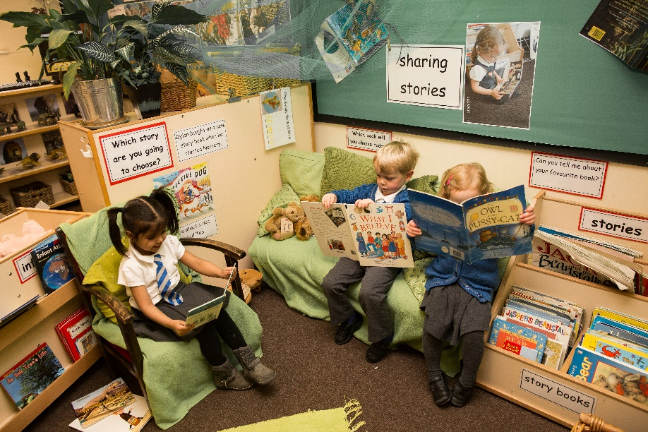

Starting School in 2019
Children start school in the academic year in which they are five years old.
We can admit up to 75 children each academic year.
Children are taught in three reception classes, each with a teacher and a teaching assistant.

Starting School Information Evening
Wednesday 5th June 2019 at 5pm
In the summer term, an Information Evening is held for parents and carers of children starting school in September.
Parents have the opportunity to meet school staff, the Head Teacher and local companies who supply school uniforms.
At the meeting parents receive a School Information Pack about the EYFS and starting school. They also have the opportunity to look around school, the dining hall and the Early Years Areas both indoors and outdoors.
Parents will also be given written notice of some really important dates at this meeting.

School Visit Dates 2019
All children take part in our ‘starting school’ transition programme.
School visits will take place:

- Week beginning 17th June 2019 for children who attend Morning Nursery.
- Week beginning 24th June 2019 for children who attend Afternoon Nursery.

Children spend one morning in Reception (the Monday, Tuesday or Wednesday) from 9.15am. Parents/Carers come back at 11.30am so they can accompany and enjoy a school lunch with their child. After lunch they go home.

On the Thursday or Friday of the same week the child spends nearly a full day in school on their own (9.15am – 2.30pm). They eat lunch with their peers supported by EY staff. After lunch they meet the lunchtime supervisory assistants when they go to play in the school playground.

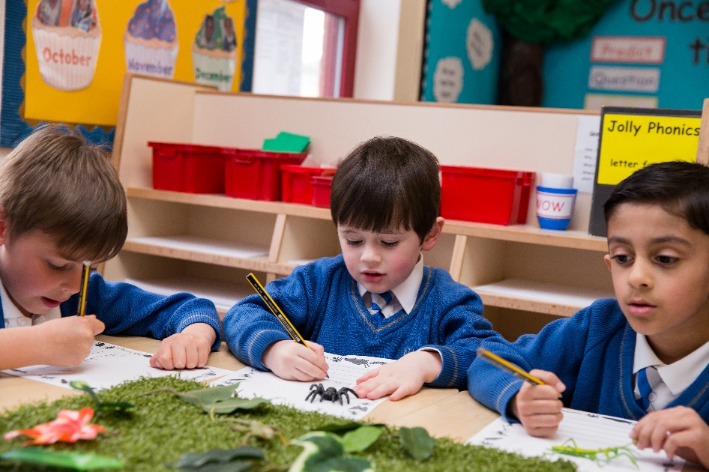

Phased Entry Dates in September 2019

At Hartburn Primary School we phase entry into Reception classes and operate shorter hours for the first 2 weeks of the school year.

This is because we have found that by introducing the children into school in smaller groups they can have more attention and help during their first few days at school; they settle better and in addition, lunchtimes and a long school day can be challenging for young children.

Reception timetable for the first 2 weeks in September 2019

For the first 2 weeks Reception hours are from 9.15am until 2.30pm
From the 3rd week in September, Reception hours are from 8.45am until 3.30pm (normal school hours)

Phased Entry
The oldest half of the year group will start school the first week of the term and attend from 9.15am until 2.30pm (reduced hours) for 2 weeks.
The younger half of the year group will start school the second week of the term and attend from 9.15am until 2.30pm (reduced hours) for 1 week.

The third week will be a normal school timetable for all Reception children.
9.00am (doors open 8.45am) until 3.30pm.

Please note children do not continue to attend Nursery during this time as we are admitting new children to the nursery class. This means parents will need to make suitable arrangements for their children to be brought to and collected from school.

Children being admitted to Reception cannot attend Breakfast Club until the 3rd week in September.
Children in the Early Years classes do not have a timetabled playtime but continue to enjoy the continuous provision provided by the EYFS outdoor area.
They share lunchtimes with older children from Key Stage One and after eating lunch they play outdoors in the school playground. We are aware that this can be a daunting experience for younger children, but know that children often like to socialise with older or younger siblings at this time. We actively encourage older children to help the younger ones, so that new children quickly feel that they have friends throughout the school community.

If you have any questions about your child starting Nursery or School, please do not hesitate to contact us and we will be happy to help.

Jane Graham (Early Years and Phase One Leader) 2019

