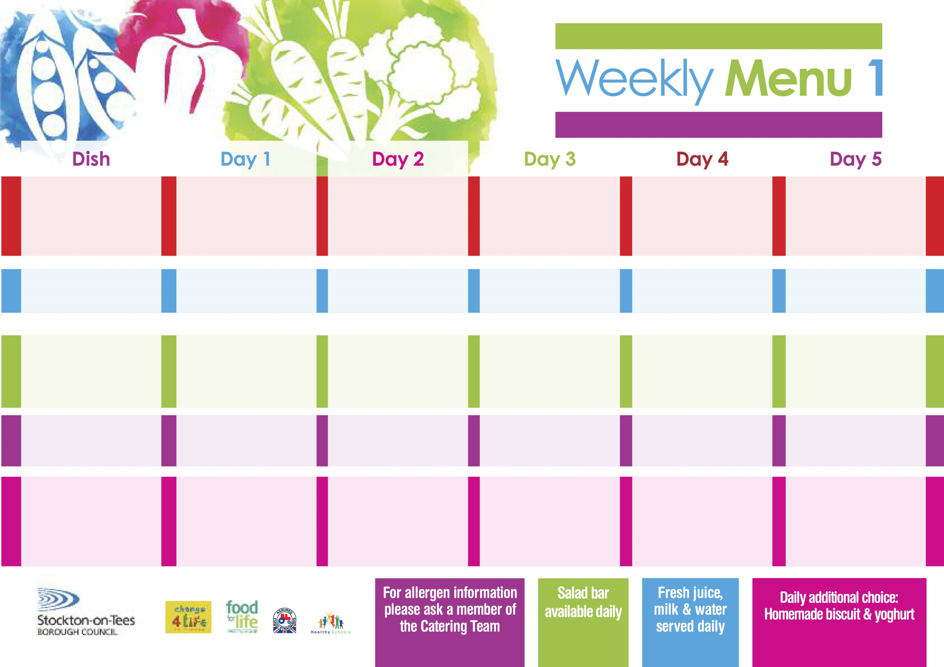

Name:

Class:

**2nd September, 30th September, 4th November & 2nd December, 2019**

**Sweet & Sour Pork**

**Hot Rice**

**Broccoli**

**Mixed Vegetables**

**Pizza (V)**

**Oven Roasted Potatoes**

**Baked Beans**

**Egg Mayonnaise Wrap (V)**

**Oven Roasted Potatoes**

**Apple & Pear Crumble**

**with Custard Sauce**

**Cold Bar**

**Melon Boat**

**Roast Turkey served with Sage & Onion Stuffing**

**Oven Roasted Potatoes**

**Cauliflower**

**Diced Swede**

**Baked Quorn Sausages (V)**

**Baked Sausages**

**Oven Roasted Potatoes**

**Spaghetti Hoops**

**Egg Mayonnaise Wrap (V)**

**Oven Roasted Potatoes**

**Ginger Pudding**

**with Custard Sauce**

**Cold Bar**

**Watermelon Slices**

**Wristband School Menu**

**+**

**Chicken Pie**

**Creamed Potatoes**

**Sweetcorn**

**Garden Peas**

**Diced Quorn Pie**

**(V)**

**Fish Stars**

**Oven Baked Potato Wedges**

**Sweetcorn**

**Garden Peas**

**Cheese Sandwiches (V)**

**Baked Potato Wedges**

**Chocolate Crunch**

**with Custard Sauce**

**Cold Bar**

**Fresh Fruit Salad**

**Mince & Suet Crust**

**Creamed Potatoes**

**Diced Carrots**

**Green Beans**

**Quorn Casserole &**

**Suet Crust (V)**

**Oven Baked Jacket Potatoes filled with:-**

**Cheese (V), Tuna & Baked Beans (V)**

**Tuna Sandwiches**

**Baked Jacket Potatoes**

**Chocolate Chip Sponge**

**with Custard Sauce**

**Cold Bar**

**Fresh Fruit Bowl**

**Fish Goujons**

**Oven Baked Chips**

**Garden Peas**

**Baked Beans**

**Penne Pasta in**

**Tomato Sauce (V)**

**Homemade Cheese Bread**

**Garden Peas**

**Tuna Sandwich**

**Oven Baked Chips**

**Syrup Sponge**

**with Custard Sauce**

**Cold Bar**

**Fresh Fruit Bowl**

**Red Choice**

**Blue Choice**

**Green Choice**

**Cold Selection**

**Desserts**