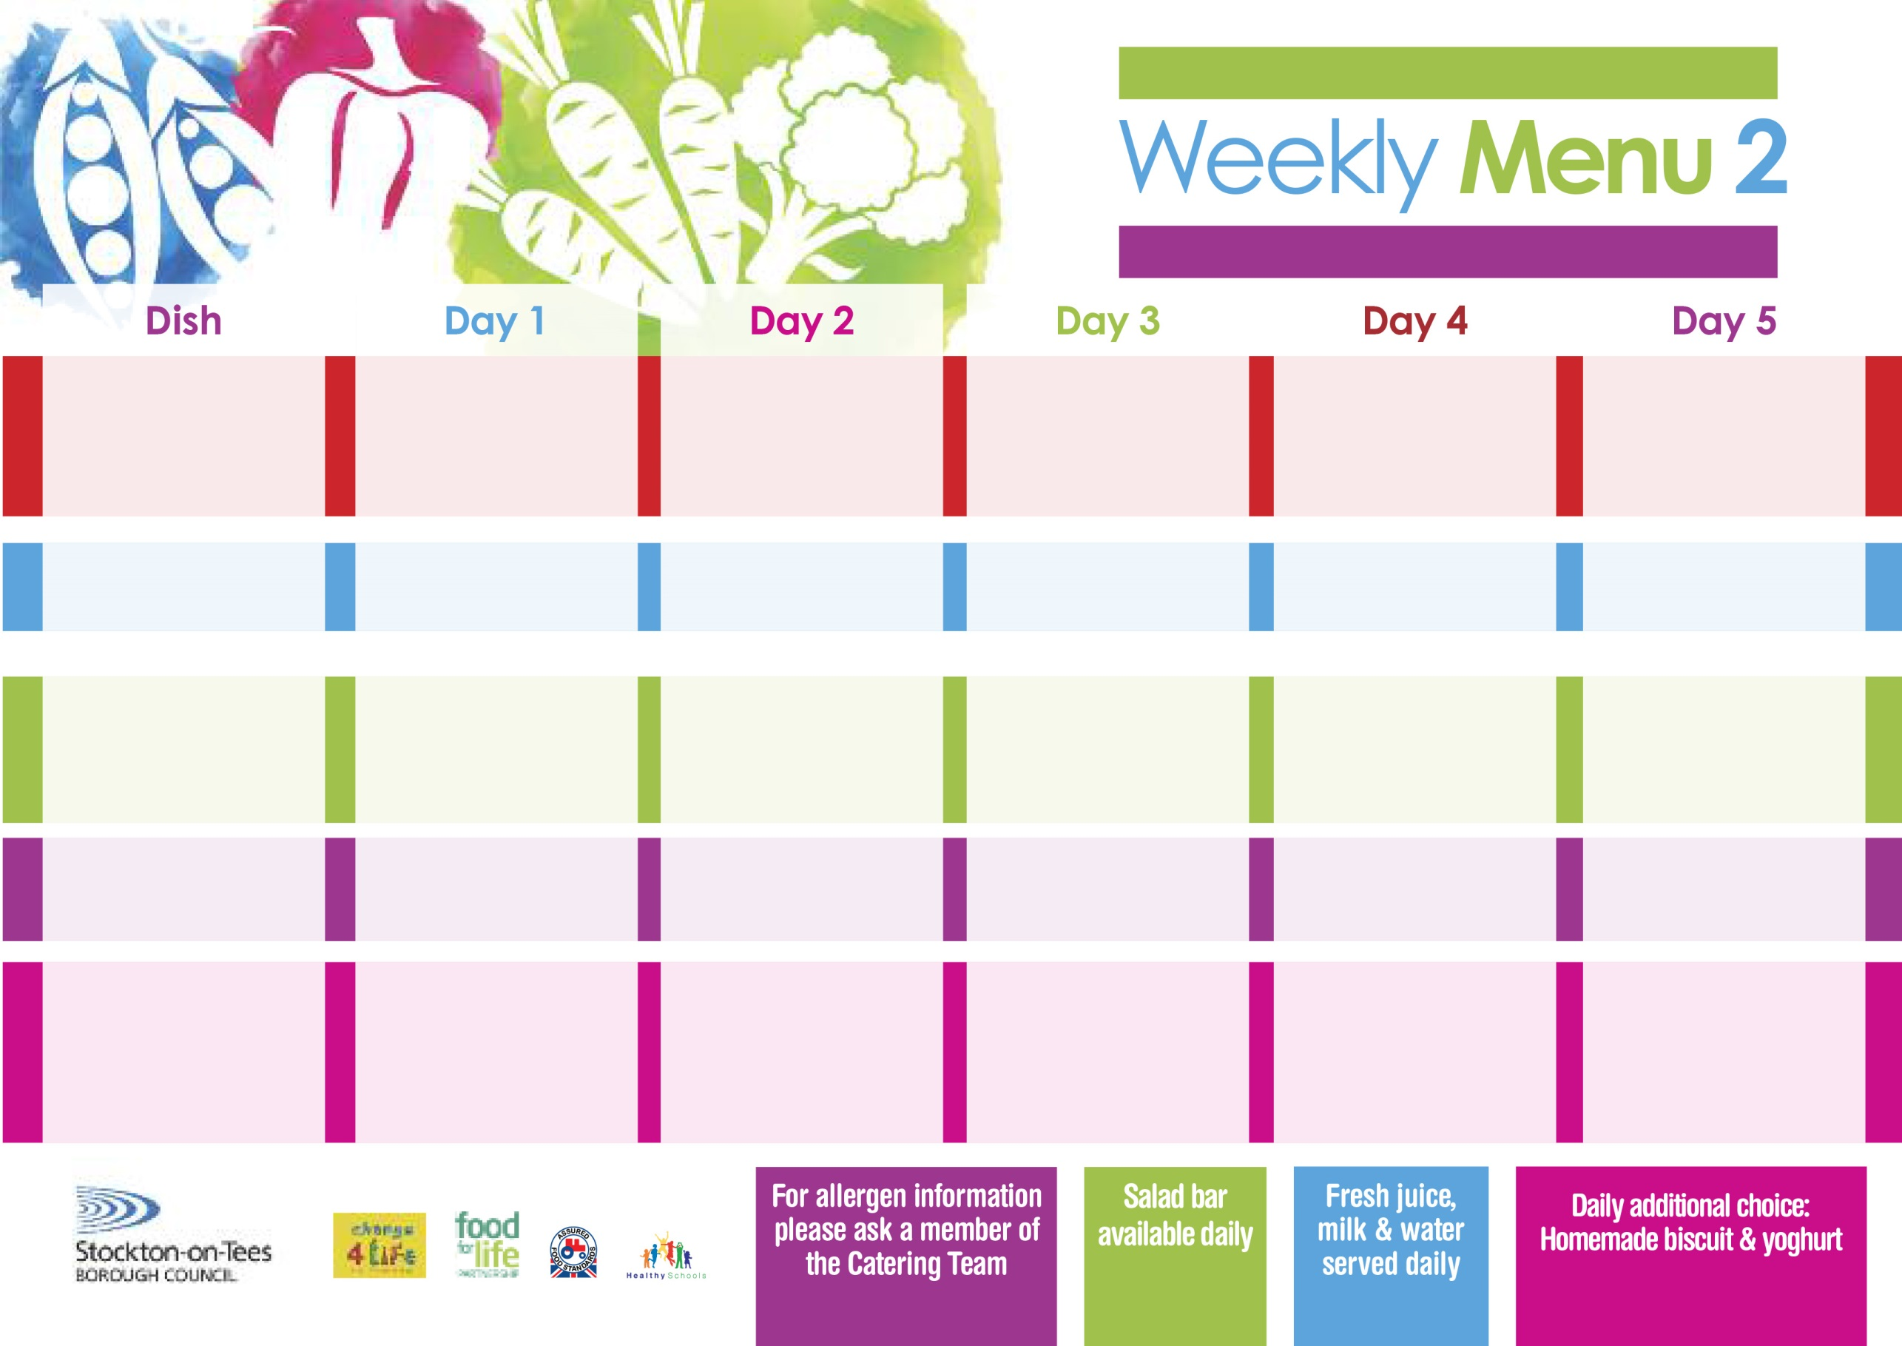

Name:

Class:

**Roast Gammon**

**served with Pineapple**

**Baby Boiled Potatoes**

**Baton Carrots**

**Cabbage**

**Homemade Quiche (V)**

**Cheese Omelette (V)**

**Baby Boiled Potatoes**

**Baton Carrots**

**Cabbage**

**Cheese Wrap (V)**

**Oven Baked Jacket Potatoes**

**Eve’s Pudding**

**with Custard Sauce**

**Cold Bar**

**Fresh Fruit Platter**

**Spaghetti Bolognaise**

**served with Garlic Bread**

**Sweetcorn**

**Mixed Vegetables**

**Quorn Bolognaise (V)**

**Sausage Roll**

**Oven Baked Potato Wedges**

**Sweetcorn**

**Spaghetti Hoops**

**Tuna Sandwich**

**Oven Baked Potato Wedges**

**Marble Sponge**

**with Custard Sauce**

**Cold Bar**

**Fresh Fruit Salad**

**9th September, 7th October, 11th November & 9th December, 2019**

**Pork Pie**

**Creamed Potatoes**

**Broccoli**

**Swede**

**Quorn Pie (V)**

**Fish Fillet Fingers**

**Baked Jacket Potatoes**

**Baked Beans**

**Ham Sandwich**

**Baked Jacket Potatoes**

**Vanilla Sponge**

**with Custard Sauce**

**Cold Bar**

**Fresh Fruit Bowl**

**Harry Ramsden**

**Fish Fillet**

**Oven Baked Chips**

**Garden Peas**

**Baked Beans**

**Pizza Whirl (V)**

**Oven Baked Chips**

**Garden Peas**

**Baked Beans**

**Tuna Sandwich**

**Oven Baked Chips**

**Creamy Rice Pudding**

**& Jam Sauce**

**Cold Bar**

**Melon Boat**

**Chicken Breast**

**Oven Roasted Potatoes**

**Garden Peas**

**Diced Carrots**

**Macaroni Cheese (V)**

**Homemade Herby Bread**

**Garden Peas**

**Diced Carrots**

**Egg Mayonnaise Wrap (V)**

**Oven Roasted Potatoes**

**Syrup Roly Poly**

**with Custard Sauce**

**Cold Bar**

**Watermelon Slices**

**Wristband School Menu**

**Red Choice**

**Blue Choice**

**Green Choice**

**Cold Selection**

**Desserts**