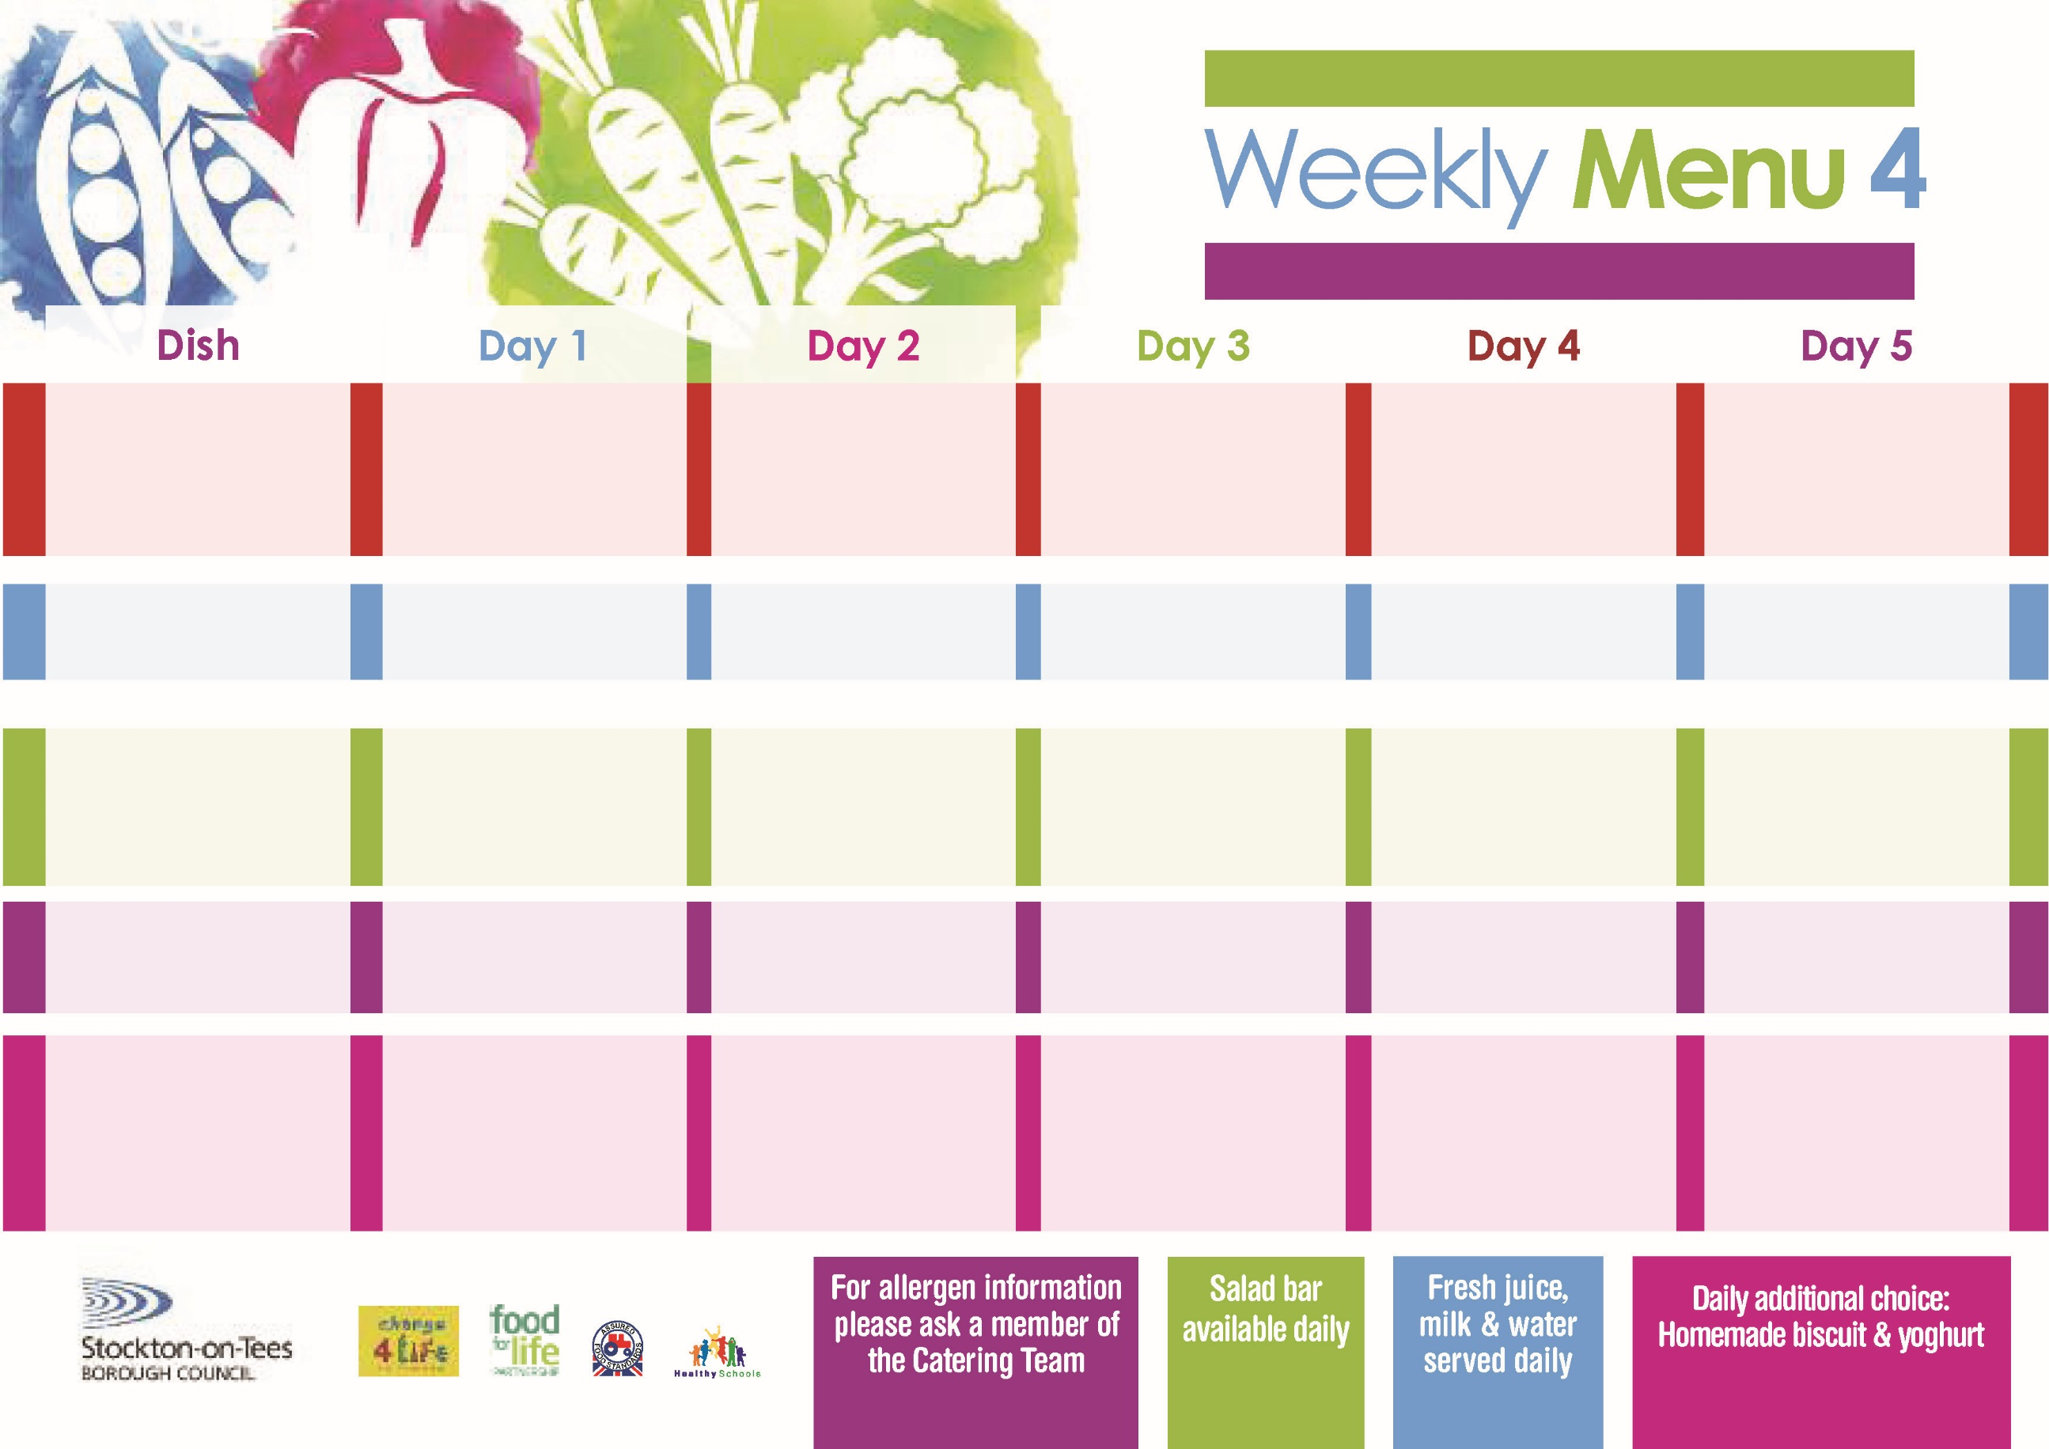

Name:

Class:

**Tempura Battered**

**Fish Fillet**

**Oven Baked Chips**

**Garden Peas**

**Baked Beans**

**Jacket Potato filled with**

**Tuna, Cheese (V) or Baked Beans (V)**

**Cheese Wrap (V)**

**Oven Baked Chips**

**Cornflake Tart**

**with Custard Sauce**

**Cold Bar**

**Fresh Fruit Kebab**

**Roast Pork with**

**Sage & Onion Stuffing**

**Baby Boiled Potatoes**

**Green Beans**

**Diced Carrots**

**Pizza (V)**

**Baby Boiled Potatoes**

**Spaghetti Hoops**

**Tuna Sandwiches**

**Baby Boiled Potatoes**

**Jam Sponge**

**with Custard Sauce**

**Cold Bar**

**Watermelon Slices**

**Turkey Burger in a Bun**

**Oven Roasted Potatoes**

**Garden Peas**

**Baked Beans**

**Quorn Burger in a Bun (V)**

**Corned Beef Pie**

**Oven Roasted Potatoes**

**Garden Peas**

**Baked Beans**

**Egg Wrap (V)**

**Oven Roasted Potatoes**

**Creamy Rice Pudding**

**& Pears**

**Cold Bar**

**Fresh Fruit Bowl**

**23rd September, 21st October & 25th November, 2019**

**Mince & Dumplings**

**Creamed Potatoes**

**Cauliflower**

**Mixed Vegetables**

**Diced Quorn & Dumplings**

**(V)**

**Tuna Melt**

**Oven Baked Jacket Potatoes**

**Spaghetti Hoops**

**Cheese Wrap**

**Oven Baked Jacket Potatoes**

**Mandarin Orange Sponge**

**with Custard Sauce**

**Cold Bar**

**Fresh Fruit Salad**

**Mediterranean Bolognaise**

**With Pasta Twirls**

**Homemade Garlic Bread**

**Sweetcorn**

**Diced Carrots**

**Mediterranean Quorn Bolognaise with Pasta Twirls (V)**

**Fish Fillet Fingers**

**Oven Roasted Potatoes**

**Baked Beans**

**Sweetcorn**

**Ham Sandwiches**

**Oven Roasted Potatoes**

**Jam Roly Poly**

**with Custard Sauce**

**Cold Bar**

**Melon Boat**

**Red Choice**

**Blue Choice**

**Green Choice**

**Cold Selection**

**Desserts**

**Wristband School Menu**