Hartburn Primary School
Early Years Admissions (Updated Summer 2021 for COVID restrictions)

Nursery Admissions

We have a 39 place Nursery. Children attend either a morning or afternoon session.
There are three members of staff at each session.

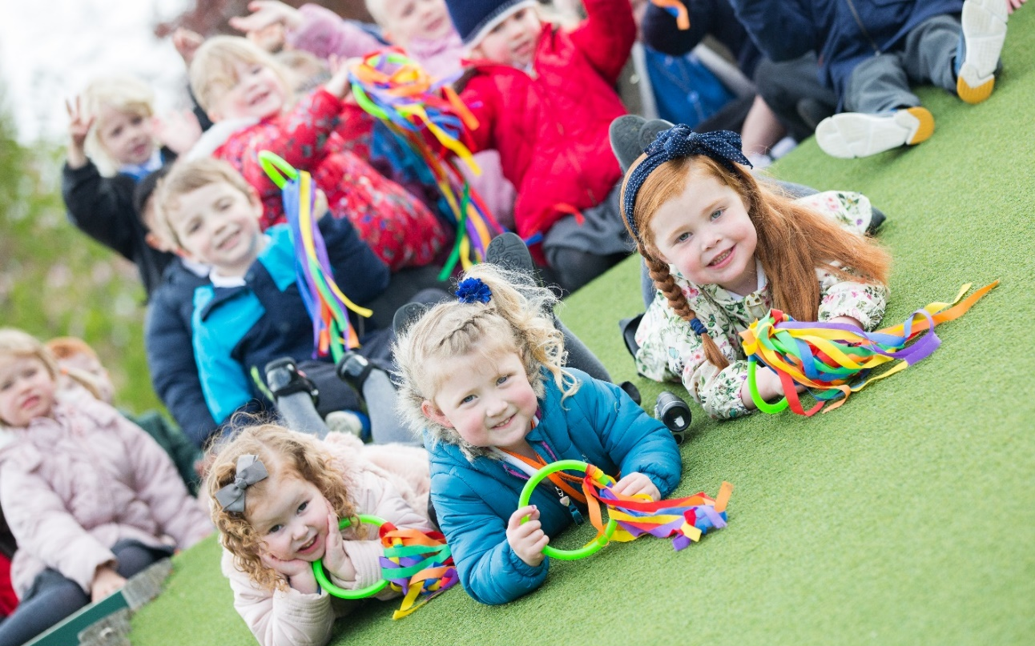

Most of our children come from either Hartburn or the surrounding local areas in Stockton-On-Tees. Many of our children know other children from having attended the same pre-school or day-care nursery, but even if children arrive here not knowing anybody; we find that they all settle in and make new friends very quickly.
Soon after the Easter holidays, staff will begin contacting parents/carers by phone, offering them a place in Nursery for their child. Children must be 3 years old before they qualify for a nursery place. We have a long waiting list so we are not able to guarantee places will be available for all children as soon as they reach three years old. Parents will be asked to express a preference for either a morning or afternoon place. However, we are not able to accommodate all requests.
Please note that a place in Nursery does not guarantee a place in school.
(Local Authority Admission Policy)

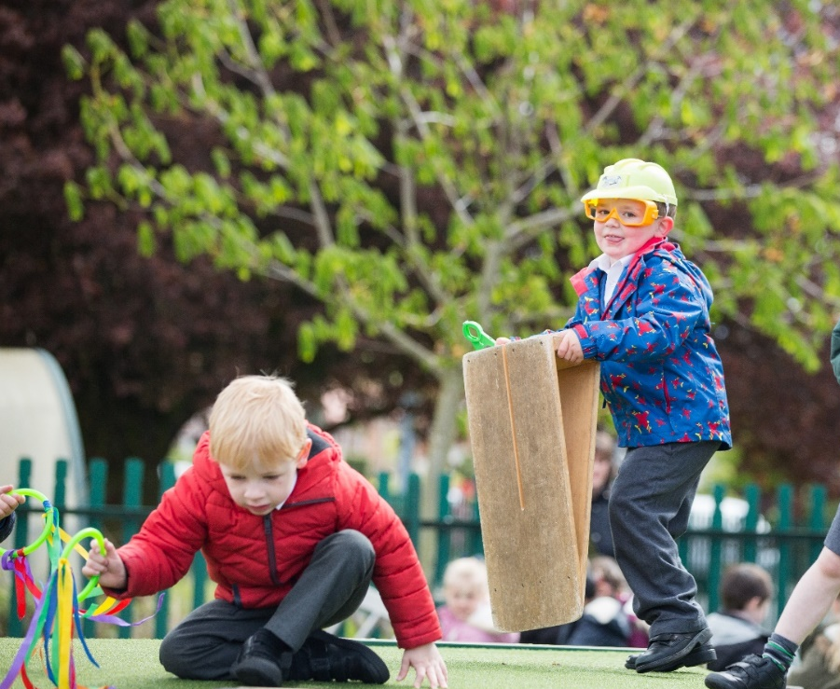

Nursery Hours
- Morning Nursery hours are from 8.30am -11.30am
- Afternoon Nursery hours are from 12.30pm – 3.30pm

After Easter, parents/carers will be contacted by telephone and offered a Nursery place for the Autumn Term. During this call, staff will arrange a date and time for parents and child to pick up a Nursery Welcome Pack from the Nursery Entrance.

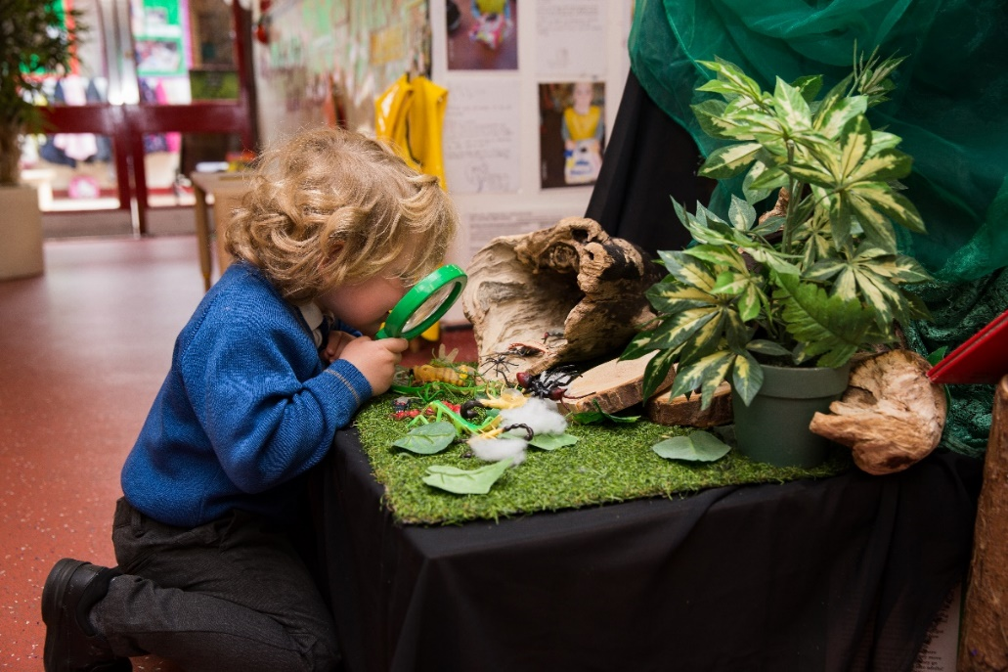

Starting Nursery Information Meeting

In the second half of the summer term, an information meeting will be arranged for parents and carers who have accepted a place for their child in nursery for the next academic year. This meeting will be held over Zoom.
Starting Nursery Information Meeting via Zoom- Wednesday 9th June 2021 at 5pm

After the meeting, parents/carers will receive a telephone call arranging a date when they can come to Nursery to collect an Education Information Pack about EY (Early Years) at Hartburn Primary School. They will have the opportunity to look at photographs, showing the Nursery indoor and outdoor environment.

Parents/Carers will also be given written notice, of an exciting date.
The date when their child can start Nursery on their own.

We work very closely with parents to ensure transition from home to Nursery is exciting and enjoyable for everybody involved. We value a parent’s judgement and if a child needs extra support/time to settle, we can organise a phased entry, until they are ready for normal hours.
Obviously in Early Years, we are able to socially distance and greet parents and carers every day as children are dropped off or collected, but we also hold two Consultation Evenings each academic year. These are for staff to celebrate and share children’s learning with parents, report on progress and discuss next steps for learning.

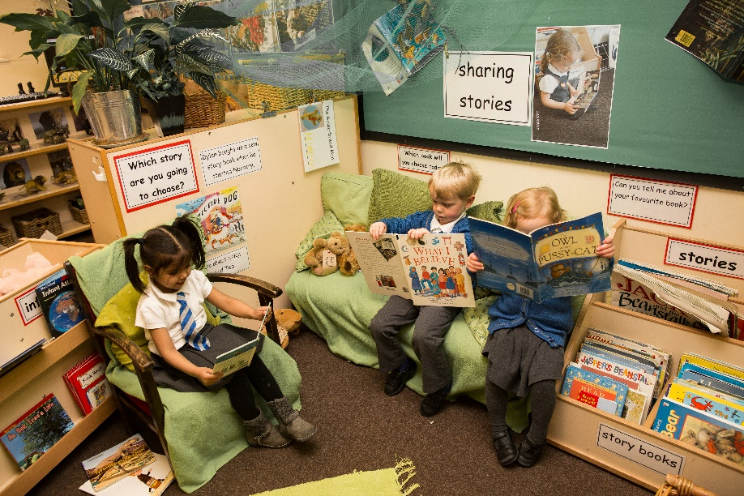

Starting School in 2021

Children start school in the academic year in which they are five years old.
We can admit up to 75 children each academic year.
Children are taught in three parallel reception classes. Reception staffing consists of three teachers and two Teaching Assistants.

Welcome to School Meeting via Zoom- Tuesday 11th May at 5pm
In the summer term 2021, a ZOOM information evening will be held for parents and carers who have accepted a place for their child in school for the next academic year. This gives them the opportunity to meet the Early Years Staff, the Head Teacher and watch a virtual tour of the Reception environment indoors and outdoors.
After the meeting, an Education Information Pack about Early Years, at Hartburn Primary School will be sent home with children who already attend Hartburn Nursery. For children who will be joining Hartburn from other settings, staff will arrange a time when parents/carers can pick up the Pack from Early Years.

The Information pack will contain written notice of the date your child will start school in September

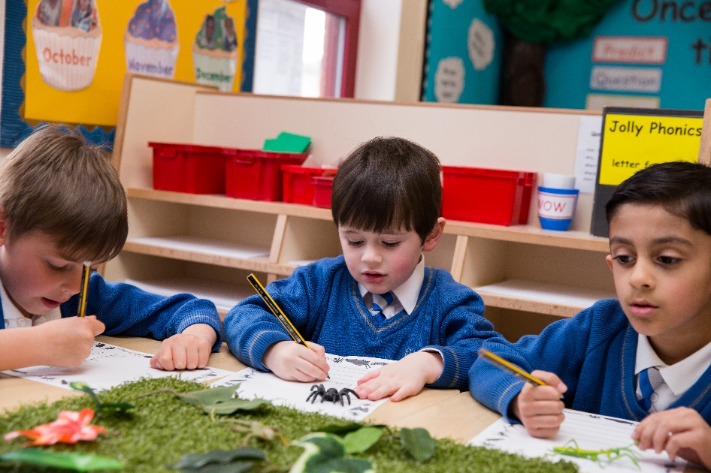

Starting School - Phased Entry Dates in September 2021

At Hartburn Primary School, we phase entry into Reception classes for the first 2 weeks of the school year.

We have found that by introducing the children into school in smaller groups they can have more attention and help during their first few days at school; they settle better and in addition, lunchtimes and a long school day can be challenging for young children.

The oldest half of the year group will start school during the first week of the term.
The younger half of the year group will start school during the second week of the term.

The third week will be a normal school timetable for all Reception children.

Please note children do not continue to attend Nursery during this time as we are admitting new children to the Nursery class. This means parents/carers will need to make suitable arrangements for their children until their school starting date.

Children in the Reception classes do not have a timetabled playtime but continue to enjoy the continuous provision provided by the EYFS outdoor area.
They share lunchtimes with the other children in their Reception Bubble and after eating lunch in the dining room, they play outdoors in the EYFS outdoor area.

If you have any questions about your child starting Nursery or School, please do not hesitate to contact school. We will be happy to help.

Mrs JE Graham 2021

