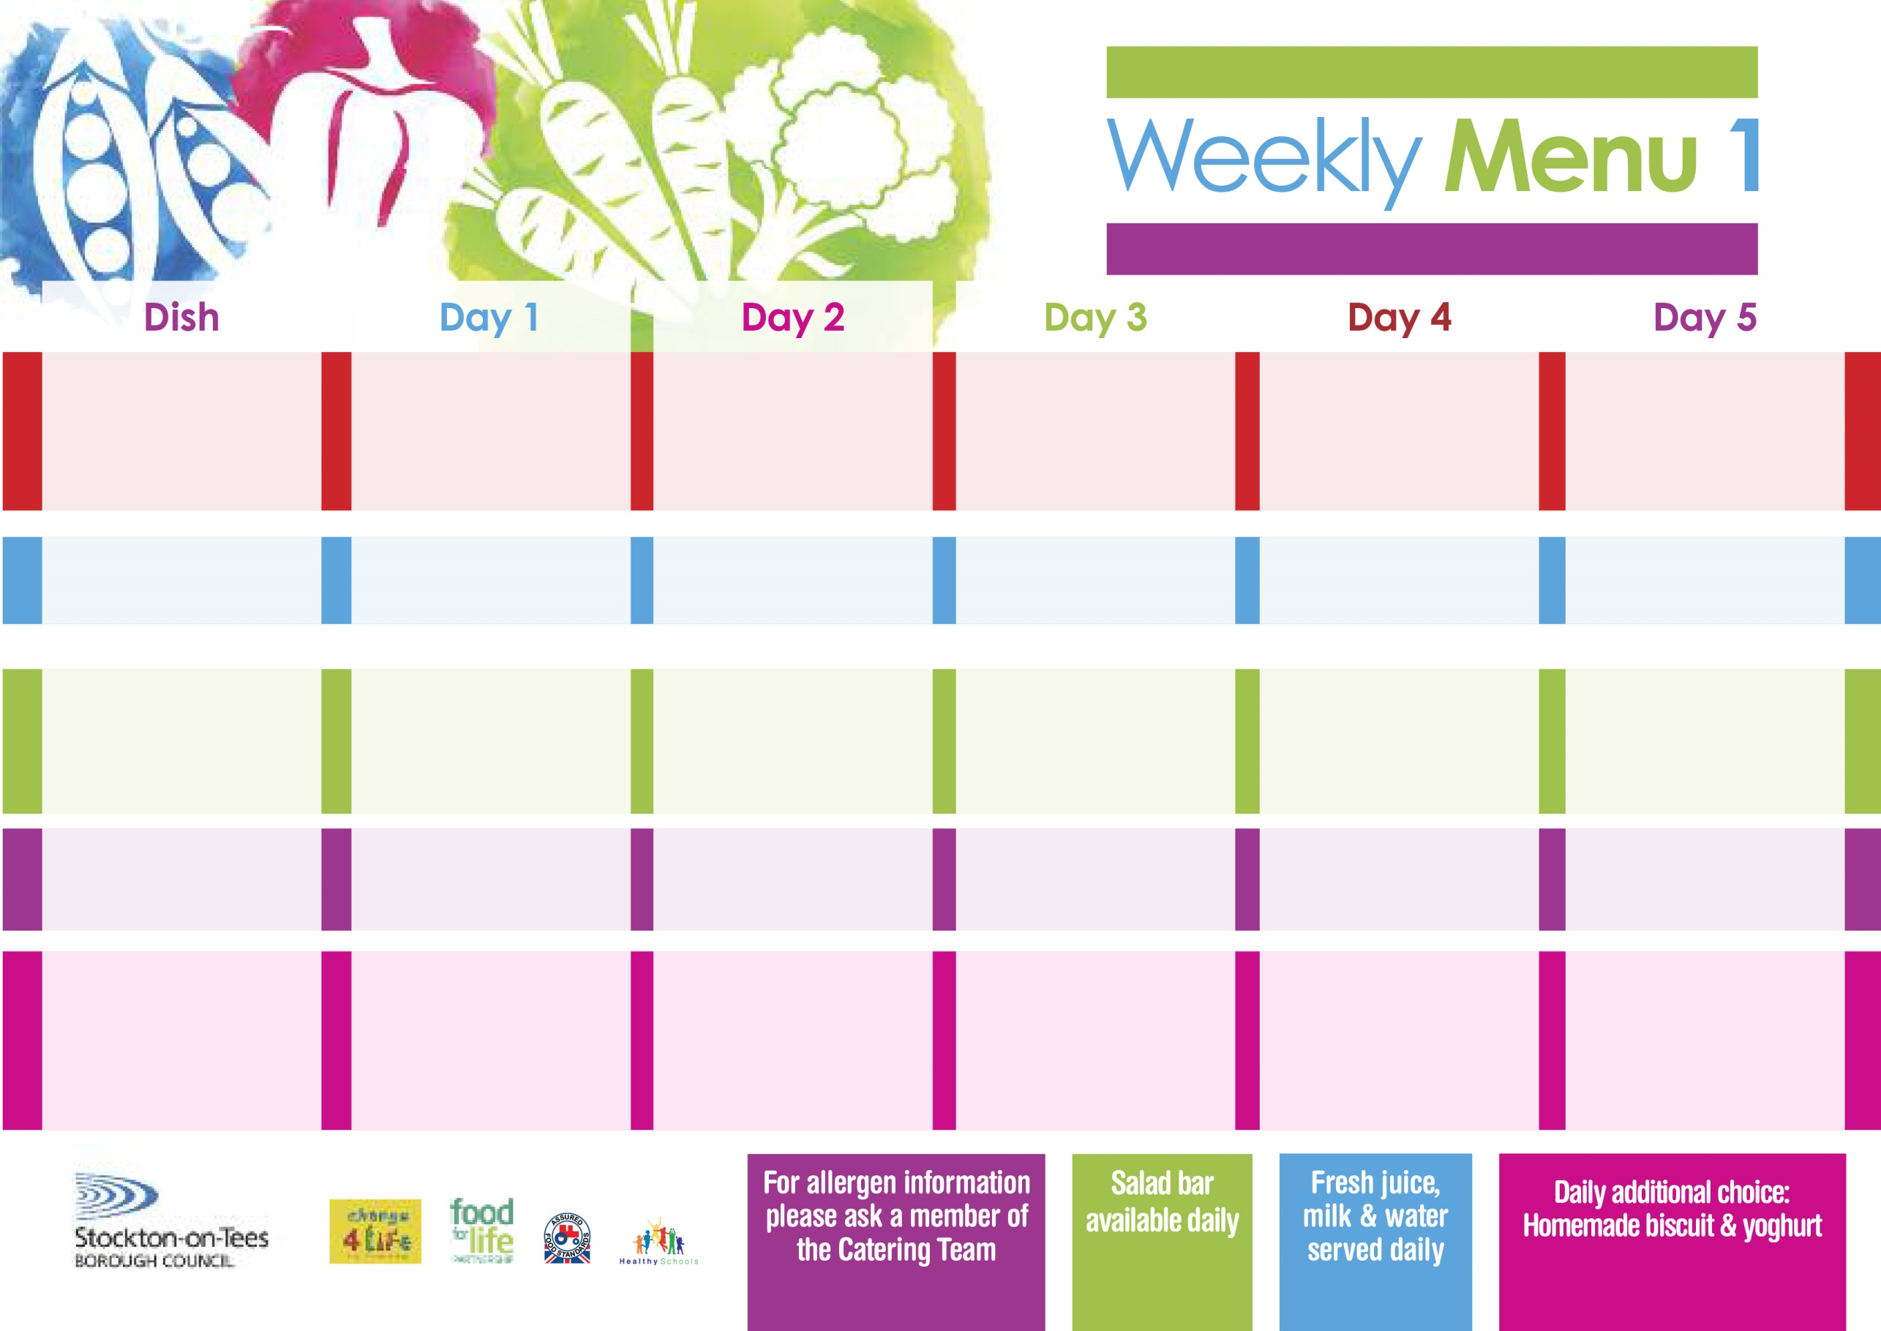

Name:

Class:

**12th April, 10th May, 14th June & 12th July, 2021**

**Chicken Casserole & Dumplings**

**Creamed Potatoes**

**Sweetcorn**

**Garden Peas**

**Quorn Casserole & Dumplings**

**(V)**

**Cheese Omelette (V)**

**Oven Baked Potato Wedges**

**Sweetcorn**

**Garden Peas**

**Tuna Sandwich**

**Baked Potato Wedges**

**Chocolate Crunch**

**with Custard Sauce**

**Cold Bar**

**Fresh Fruit Salad**

**Buttermilk Chicken**

**Fillet Breast**

**Oven Roasted Potatoes**

**Cabbage**

**Mixed Vegetables**

**Homemade Pizza (V)**

**Oven Roasted Potatoes**

**Baked Beans**

**Egg Mayonnaise Wrap** **(V)**

**Oven Roasted Potatoes**

**Eve’s Pudding**

**with Custard Sauce**

**Cold Bar**

**Melon Boat**

**Roast Gammon served with Pineapple**

**Baby Boiled Potatoes**

**Cauliflower**

**Diced Swede**

**Baked Quorn Sausages (V)**

**Baked Sausages**

**Baby Boiled Potatoes**

**Spaghetti Hoops**

**Egg Mayonnaise Wrap (V)**

**Oven Roasted Potatoes**

**Apple Crumble**

**with Custard Sauce**

**Cold Bar**

**Watermelon Slices**

**Wristband School Menu**

**+**

**Spaghetti Bolognaise**

**Homemade Garlic Bread**

**Diced Carrots**

**Broccoli**

**Quorn Bolognaise (V)**

**Fish Fillet Fingers**

**Oven Baked Jacket Potatoes**

**Spaghetti Hoops**

**Cheese Sandwich (V)**

**Baked Jacket Potatoes**

**Pineapple Upside Down cake**

**with Custard Sauce**

**Cold Bar**

**Fresh Fruit Bowl**

**Fish Goujons**

**Oven Baked Chips**

**Garden Peas**

**Baked Beans**

**Penne Pasta in**

**Tomato Sauce (V)**

**Homemade Cheese Bread**

**Garden Peas**

**Cheese Sandwich (V)**

**Oven Baked Chips**

**Vanilla Sponge**

**with Custard Sauce**

**Cold Bar**

**Fresh Fruit Bowl**

**Red Choice**

**Blue Choice**

**Green Choice**

**Cold Selection**

**Desserts**