Hartburn Primary School
Early Years Admissions

Nursery Admissions

We have a 39 place Nursery. Children attend either a morning or afternoon session.
There are three full time staff and two part time staff.

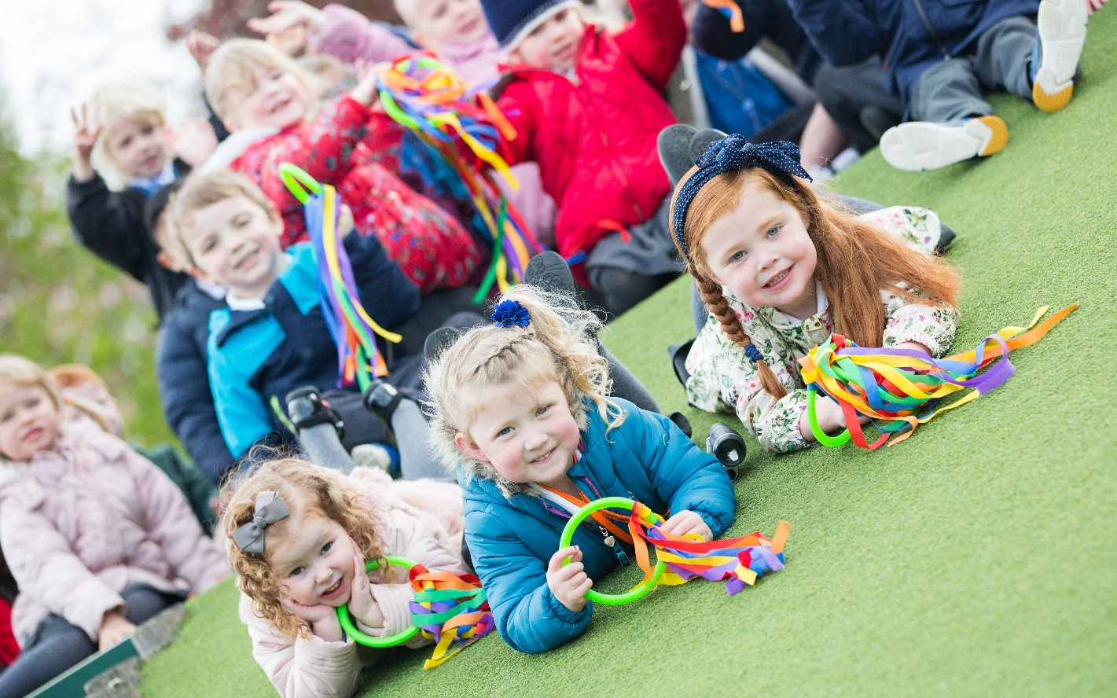

Most of our pupils come from either Hartburn or the surrounding local areas in Stockton on Tees. Many children know each other from having attended the same pre-school or day-care nursery, but even if children arrive here not knowing anybody; we find that they all settle in and make new friends very quickly.
Soon after the Easter holidays, office staff will begin contacting parents/carers by letter offering them a place in Nursery for their child. Children must be 3 years old before they qualify for a Nursery place. We have a long waiting list so we are not able to guarantee places will be available for all children as soon as they reach three years old. Parents will be asked to express a preference for either a morning or afternoon place. However, we are not always able to accommodate all requests.
Please note that a place in Nursery does not guarantee a place in Hartburn Primary School.
(Local Authority Admission Policy)

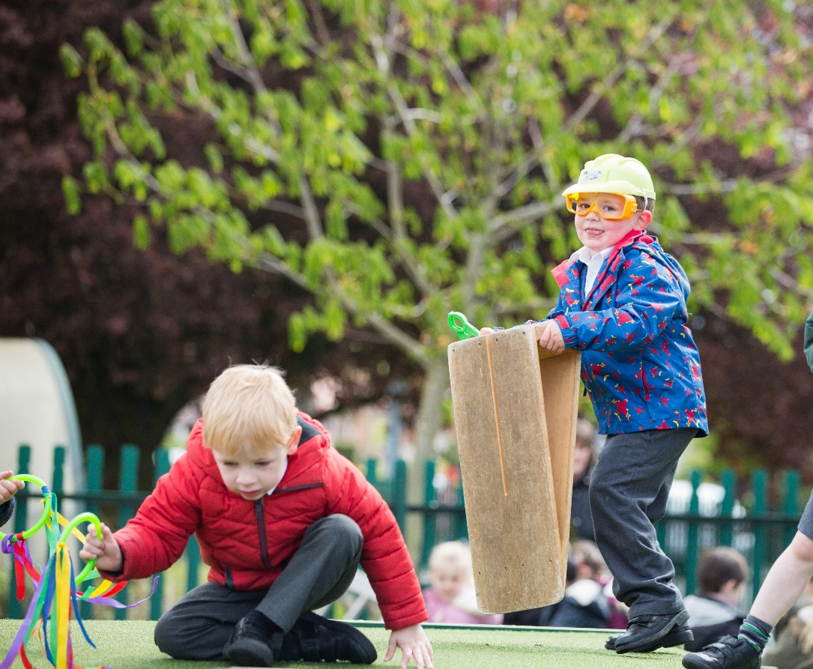

Nursery Hours
- Morning Nursery hours are from 8.45am – 11.45 am
- Afternoon Nursery hours are from 12.30pm – 3.30pm

Parents are welcome to visit the school before they accept a place but most people accept by return of post, as we are an extremely popular school. A letter offering either a morning or afternoon place will be sent and parents/carers will be invited to attend a meeting in June.

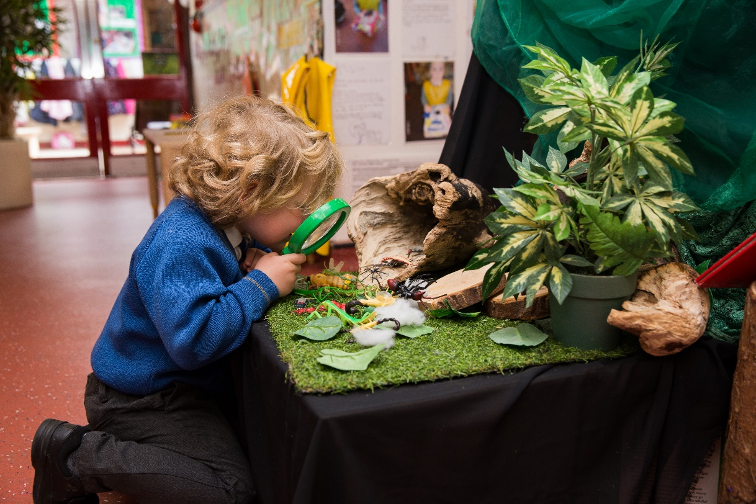

Starting Nursery Information Meeting

In the summer term, an information evening is organised for parents and carers who have accepted a place for their child in Nursery for the next academic year. This gives them the opportunity to meet Early Years staff, Phase Leader, Head Teacher and local companies who supply school uniforms.
At the meeting parents receive an Education Information Pack about EY (Early Years) at Hartburn Primary School and will have the opportunity to look around school and spend some time in the Early Years environments both indoors and outdoors.

Parents are given written notice of three important dates:
A date when EY staff will come and visit children in their own home. A ‘Home Visit’.
A date for both parent/carer and child to come to Nursery for a ‘Play Visit’
A date when the child can start Nursery on their own.

Before children visit Nursery, staff arrange a HOME VISIT. This ensures children feel secure as they have their own toys/books around them and staff can chat to both child and parent/carer in a familiar setting.
After the home visit, the parent/carer and child are invited to a PLAY VISIT at Nursery. This is usually for about an hour and gives children opportunity to explore the Nursery and meet the EY practitioners. A Hartburn book bag and contact book will be given and together parent/carer and child may choose their first book to share and enjoy at home.
If all goes well on the play visit, children usually start Nursery within the next few weeks.
We work very closely with parents/carers to ensure transition from home to Nursery is exciting and enjoyable for everybody involved. We value your judgement and if a child needs extra support/time to settle we can organise a phased entry, until they are ready for normal hours.
Obviously in Early Years, we chat informally to parents and carers every day as children are dropped off or collected, but we also hold two Parent Evenings each academic year. These are for staff to celebrate and share children’s Learning Journeys with parents, report on progress and discuss next steps for learning.

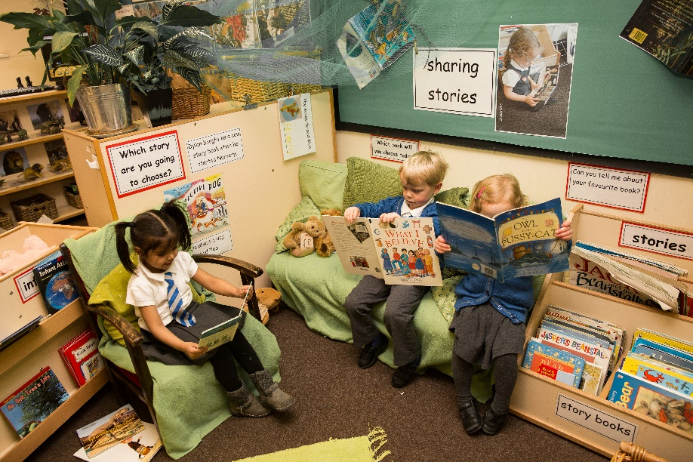

Starting School
Children start school in the academic year in which they are five years old.
We can admit up to 75 children each academic year.
Children are taught in three reception classes, each with a teacher and a teaching assistant.

Starting School Information Evening

In the summer term, an Information Evening is organised for parents and carers of children starting school in September.
Parents have the opportunity to meet school staff, the Head Teacher and local companies who supply school uniforms.
At the meeting parents receive a School Information Pack about the EYFS and starting school. They also have the opportunity to look around school, the dining hall and the Reception classrooms both indoors and outdoors.
Parents will be given written notice of some important dates at this meeting.

School Visit Dates
All children take part in our ‘starting school’ transition programme.
School visits will take place:

Children spend one morning in Reception (the Monday, Tuesday or Wednesday) from 9.15am. Parents/Carers come back at 11.30am so they can accompany and enjoy a school lunch with their child. After lunch, children go home with their adult.

On the Thursday or Friday of the same week children, spend nearly a full day in school on their own (9.15am – 2.30pm). They eat lunch with their peers supported by EY staff. After lunch they meet the lunchtime supervisory assistants when they go to play in the school playground.

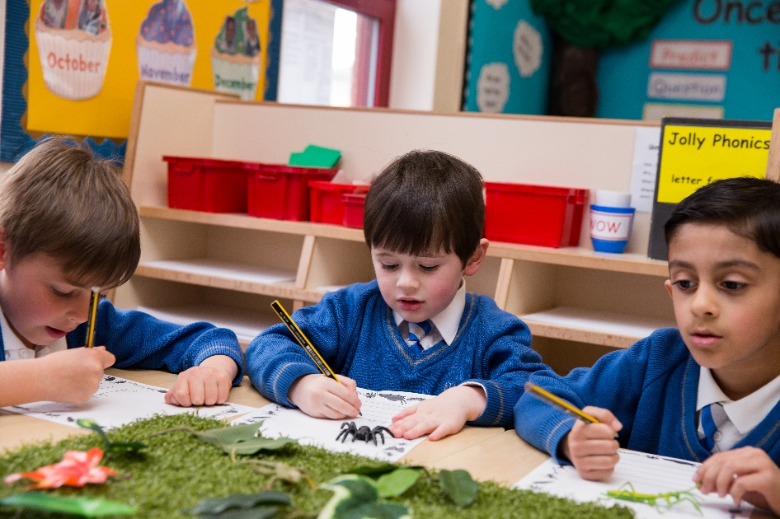

Phased Entry Dates in September

At Hartburn Primary School we phase entry into Reception classes.

We find that by introducing the children into school in smaller groups they can have more attention and help during their first few days at school, they settle better and in addition, lunchtimes and a long school day can be challenging for young children.

The oldest half of the year group will start school the first week of the term.
The younger half of the year group will start school the second week of the term.

Please note children do not continue to attend Nursery during this time as we are admitting new children to the Nursery class. This means parents/carers will need to make suitable arrangements for their children to be brought to and collected from school.
Children in the Early Years classes do not have a timetabled playtime but continue to enjoy the continuous provision provided by the EYFS outdoor area.
They share lunchtimes with older children from Key Stage One and after eating lunch they play outdoors in the school playground. We are aware that this can be a daunting experience for younger children but we actively encourage older children to help the younger ones, so that new children quickly feel that they have friends throughout the school community.

If you have any questions about your child starting Nursery or School, please do not hesitate to contact us and we will be happy to help.

Jane Graham (Early Years Leader)

