**Science Monitoring 2023 Year 1** Autumn Term

**Progress in science:**

We know all about new words that we didn’t know before. We colour them red if we don’t know then green when we know them. We are really good at sorting things into different groups. We know that magnetic things stick together. I know what all of our senses are now.

**We learn new skills:**

We learn about things that are the same and things that are different. We are good at sorting things. We learn new words.

I know that waterproof means because if it was raining and you had an umbrella, you wouldn’t get soaked. I know transparent means to see through things.

**Pupil Voice**

**What we are learning:**

We have been learning about our senses.

Before that we were learning about materials.

**Our thoughts about Science:**

I like science. It was fun when we went on a hunt to look for different materials. I like learning about our senses.

**Our Next Steps:**

We need to learn more words and do more sorting.

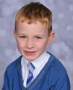

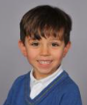

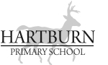

**Book Look**

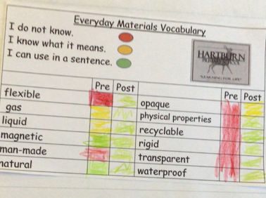 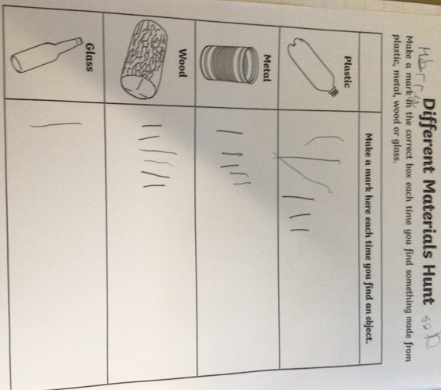 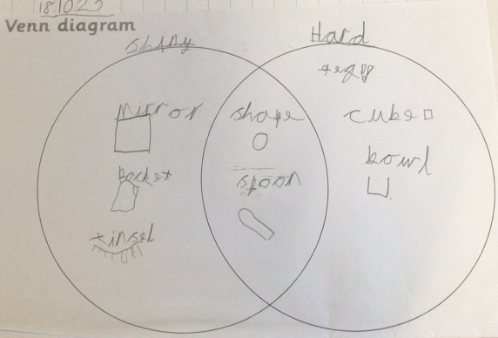

**Strengths:**

* The children enjoy science due to the practical investigations.
* The children are able to see that they are making progress by learning new vocabulary by using the pre and post vocabulary assessments.
* Work is well-presented
* **Next steps:**
* Continue to develop investigation skills.
* Understand that there are different types of investigations.
* Introduce concept maps as a way of organising information and making links between

scientific concepts. Record as a whole class.