**Science Monitoring 2023 Year 2** Autumn Term

**Progress in science:**

I know the 5 senses now.

We use the word list at the start to check what we do and don’t know. Red is if you don’t know it; green is when you know it.

We do lots of counting and bar charts like in maths.

**We learn new skills:**

We can sort things into different groups by looking at them.

We can make bar charts to show different numbers of things.

**Pupil Voice**

**What we are learning:**

We learned all about materials. Now we’re learning about our senses.

**Our thoughts about Science:**

I like learning about new things.

I think sorting things into groups is fun.

**Our Next Steps:**

We need to learn more about our senses. After Christmas we will earn something new and learn some new words. If we know them, we will colour them in green; if we don’t know them, we will colour them red. If we don’t know the words, we will learn what they mean.

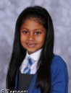

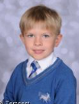



**Book Look**

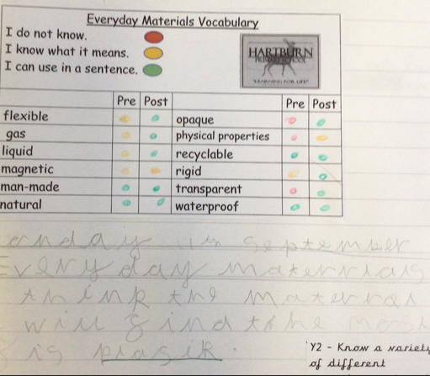 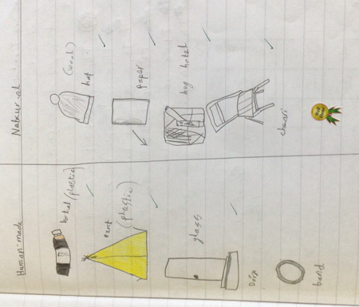 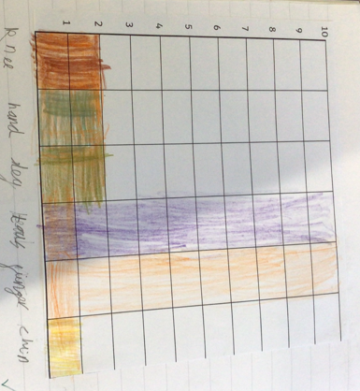 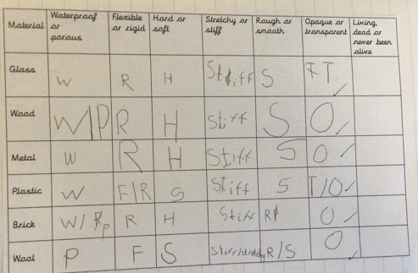

**Strengths:**

* The children had completed a variety of investigations.
* Children demonstrated a good level of understanding about materials and senses.
* Work was differentiated, well presented and the children were able to use scientific age-appropriate vocabulary.
* Children were able to identify their progress through the pre and post learning vocabulary sheets.

**Next steps:**

* Children to be more aware of the different types of investigations they carry out.
* Children to continue to develop their report writing skills in preparation for KS2.
* Introduce concept maps as a way of organising information and making links between

scientific concepts. Record as a whole class.