**Science Monitoring 2023 Year 3** Autumn Term

**Progress in science:**

**We have made progress from KS1 because we can do more complicated experiments. In Y1 and 2 we learnt about our senses, but in Y3 we have learnt more about our bodies like naming different bones in our bodies. We can see the progress we have made because we colour words that we don’t know in red at the start of a topic then colour them green when we do know them.**

**We learn new skills:**

**We now know that biceps get shorter, and triceps relax when people move their arms. We can do different experiments. I enjoyed doing the fat test so we could see how much fat different foods contained.**

**Pupil Voice**

**What we are learning:**

**We have been learning about human and animal skeletons. We have also been learning about healthy foods and that some foods are good for different types of people.**

**Our thoughts about Science:**

**I like learning about bones because I would like to work with animals, so it has been useful.**

**I want to be an inventor, so I like learning about how things work.**

**Our Next Steps:**

**We need to learn more science so we can get a good job when we are older.**



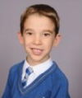

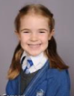

**Book Look**

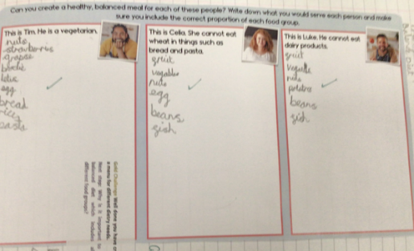 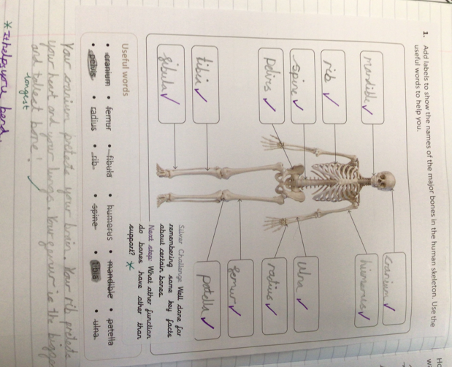 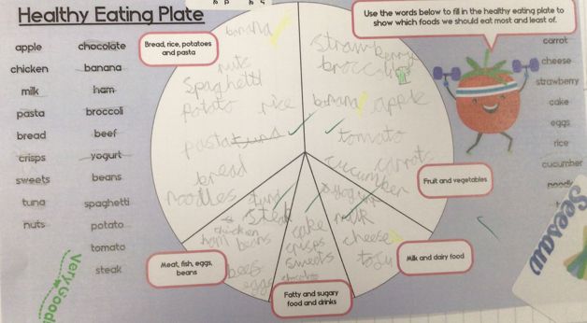 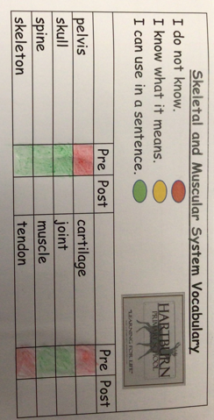

**Strengths:**

* High levels of engagement as a result of practical investigations which make learning memorable.
* The children are using age- appropriate vocabulary in their written and verbal explanations.
* Children had a good understanding of the different investigation types.

**Next steps:**

* Develop report writing skills.
* Introduce concept maps as a way of organising information and making links between

scientific concepts. Record in table groups.