**Science Monitoring 2023 Year 4 Autumn Term**

**Progress in Science:**

**We use what we have learnt in earlier years to help us learn more now we are older.**

**We colour in the topic words at the start- red if we don’t know them and green if we do know them. I know more words now than I did at the start of the topic.**

**We learn new skills:**

**We know that cartilage is a type of bone, but not a proper one. We do different experiments and learn how to record the information.**

**Pupil Voice**

**What we are learning:**

**We have been learning about different skeletons, types of bones, joints and cartilage. We’ve also been learning about healthy and unhealthy foods.**

**Our thoughts about science:**

**I like doing experiments and trying different things. I want to be a biologist, so science is useful. Our teachers talk about different careers in science which helps us to think about what we want to do when we leave school.**

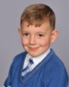

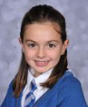

**Our Next Steps:**

I’m looking forward to the next topic which is forces. I already know about magnets so I want to find out more about other forces.



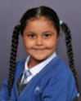

**Book Look**

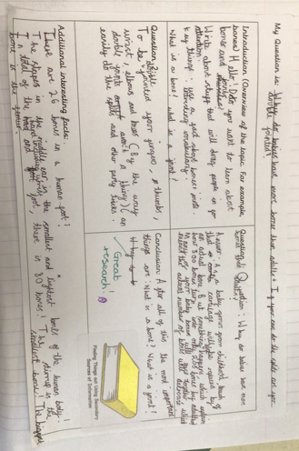 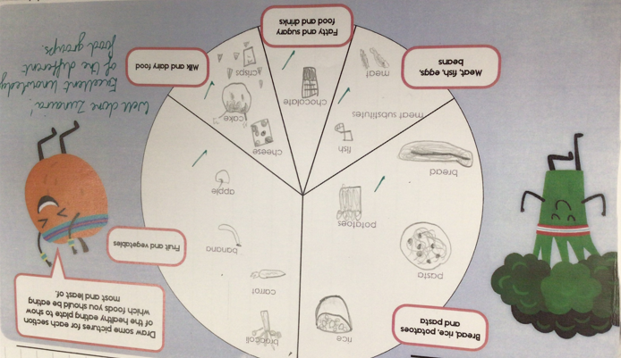 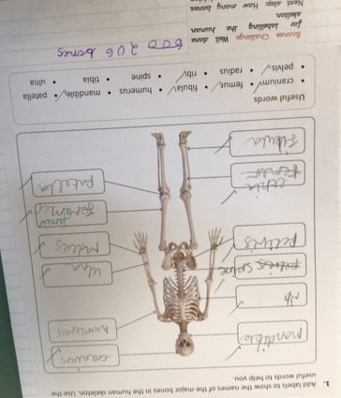

**Strengths:**

* High levels of engagement as a result of practical investigations which make learning memorable.
* The children are using age- appropriate vocabulary in their written and verbal explanations.
* Children had a good understanding of the different investigation types.

**Next steps:**

* Continue to develop investigation skills.
* Introduce concept maps as a way of organising information and making links between

scientific concepts. Record in table groups.