**Science Monitoring 2023 Year 5 Autumn Term**

**Progress in Science:**

**We use the pre and post vocabulary words to see if we have learned the new topic words.**

**We also highlight the knowledge organisers when we learn something new.**

**We learn new skills:**

**Science helps us to understand the world. It also helps us to learn maths when we record information on graphs.**

**We learned how to use force meters which we couldn’t do before.**

**Pupil Voice**

**What we are learning:**

**In the first half-term we learnt about forces. This half term we have been learning about Earth and Space.**

**Our thoughts about science:**

**We like doing different experiments and testing things.**

**Science is really useful because it will help us to get a job when we leave school.**

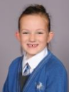

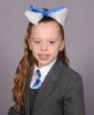

**Our Next Steps:**

**We are looking forward to doing more experiments and learning more about different science topics.**



**Book Look**

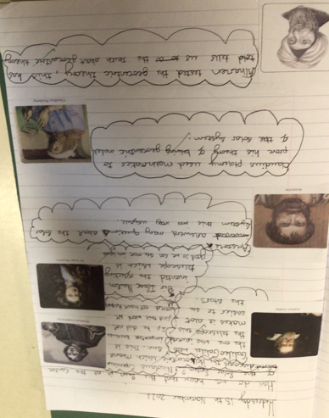 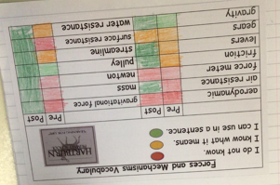 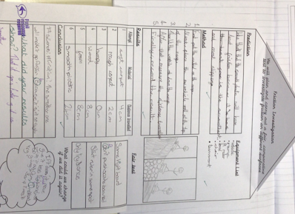 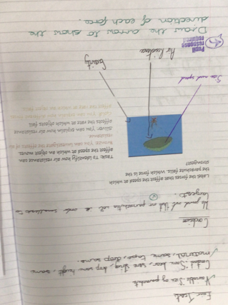

**Strengths:**

* High levels of engagement as a result of practical investigations which make learning memorable.
* The children are using age- appropriate vocabulary in their written and verbal explanations.
* Children had a good understanding of the different investigation types.

**Next steps:**

* Continue to develop report writing skills for KS3 readiness.
* Introduce concept maps as a way of organising information and making links between

scientific concepts. Create individual concept maps.