**Science Monitoring 2023 Year 6 Autumn Term**

**Progress in Science:**

**We use pre and post vocabulary sheets to assess our understanding of scientific vocabulary before we learn a new topic and when we finish it. We also use concept cartoons at the start of a topic which encourage us to discuss different theories. In Y1/2 and Y3/4, we start with the basics, but we develop our understanding in more depth in Y5 /6.**

**We learn new skills:**

**We learn how to do different investigations and use new resources like force meters.**

**Pupil Voice**

**What we are learning:**

**We have been learning about Forces and Mechanisms and Earth and Space.**

**Our thoughts about science:**

**Science is useful because it links to other subjects like maths, English and geography. I like learning about how theories evolve such as the Flat Earth theory and the Geocentric and Heliocentric theories. I enjoy the variety of different topics within science. I enjoy testing theories and doing experiments. Our trip to the Life Centre was good fun and we learnt a lot about Earth and Space.**

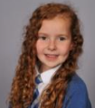

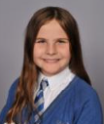

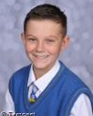

**Our Next Steps:**

**We are looking forward to doing more investigations in our next topic.**



**Book Look**

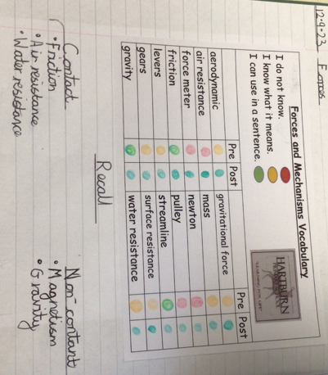 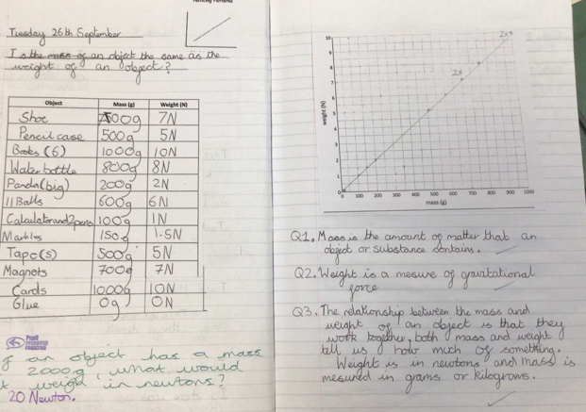 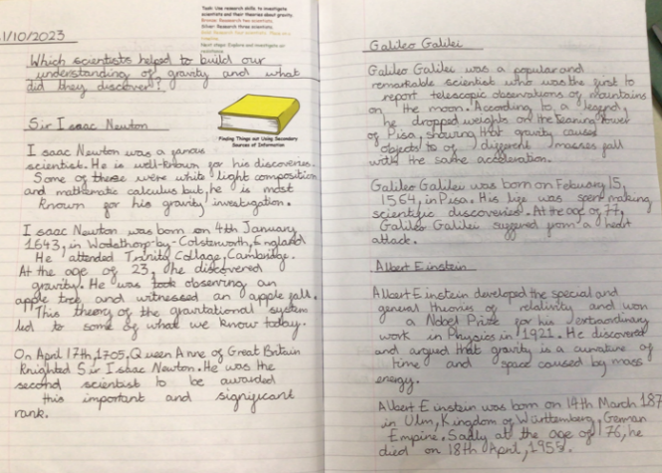 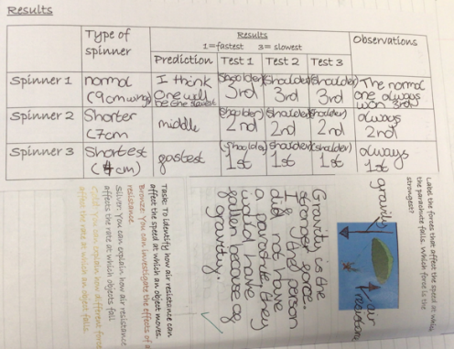

**Strengths:**

* High levels of engagement as a result of practical investigations which make learning memorable.
* The children are using age- appropriate vocabulary in their written and verbal explanations.
* Children had a good understanding of the different investigation types.

**Next steps:**

* Continue to develop report writing skills for KS3 readiness, e.g. more detailed conclusions using evidence from the results.
* Introduce concept maps as a way of organising information and making links between

scientific concepts. Create individual concept maps.