**Eco 2022**

**What does your class do to help be part of an Eco School?**

“We turn the lights off when we are not in the classroom.”

“Our class makes sure we put all of our waste paper in the recycling bin”.

“We only use one tissue to dry our hands”.

**What has your teacher taught you about being an Eco School?**

“To pick up litter to make the world a better and cleaner place.”

“We must make sure we work hard to keep our wildlife area safe and tidy so that animals can live there and survive”.

**Pupil Voice**

**What does being an Eco School mean?**

“We are trying to protect the world by making sure we put litter in the bin and keep our school clean.”

**What else could we do in school?**

**“**Reduce the amount of paper we use in class and not use so many worksheets.”

“Make sure children don’t miss pages in their books because that is a waste.”

“We need to make sure we put lids on pens and glue sticks so that they don’t dry out because that is a big waste and uses lots more plastic.”

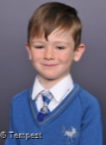

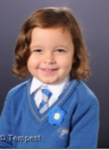

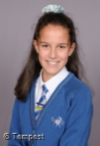

**Our thoughts about being an Eco School…**

“Every Tuesday the litter picking team litter pick at lunch time and after school, I really love helping.”

“It is good because we need to save our world.”

“It helps to teach children even in nursery all about looking after our environment.”



**File Look**

**Strengths:**

**Next steps:**