**Humanities Monitoring 2022 KS1**

**Enquiring minds – History**

I like learning about people that were different to me. I also like learning about History in other subjects too. In Science we learnt about Neil Armstrong and Buzz Aldrin and the first man on the moon.

Spring Term

**Enquiring minds – Geography**

I think it’s fun learning where towns, cities and countries are. I love looking at globes and maps and finding places I know and finding new places too.

**Pupil Voice**

**Progress in History and Geography**

When I’m stuck in my lessons I can ask my teacher for help. There’s always things that help me on the board. I know I’m doing well in my lesson if I can put my hand up and answer a question when the teacher asks.

**What we are learning**

‘Bright Lights, Big City’ – we are learning about cities close to use like York and big cities like London.

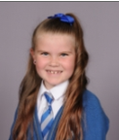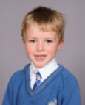

**What does History and Geography look like in Year 4?**

We do History and Geography. When we learnt about Pirates we learnt about places they went to like the Caribbean Sea. We learnt about famous people from a long time ago like Black Beard.