Humanities Monitoring 2022 LKS2
Enquiring minds – Geography
I like to learn about where different places are so when a country is mentioned on the news I can say ‘Oh I know where that is – I have learnt about it.’
I enjoy using maps and atlases. We had match mountains to where they are in the world. This was tricky but when I found the place using the atlas I was really pleased with myself.

Enquiring minds – History
I enjoy learning about how people behaved long ago. I also find it interesting learning about why things happened – like a battle and who started it. I love looking at how our planet has changed over time.
I enjoy learning about what happened and when and looking at the order on a timeline. I sometimes look at the timeline in our corridor.

Spring Term

Pupil Voice

Progress in History and Geography
I find maps confusing but I can ask my learning partner for help when I’m stuck.
I think putting things in time order of when they happened can be tricky but sometimes we have pictures on the board to help us. Miss Hoskin stops the class and shows us things on the board to help us.
What we are learning
We are learning about rocks and the layers of the Earth – ‘Rocks, relics and rumbles’

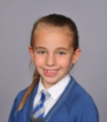
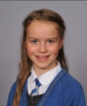
What does History and Geography look like in Year 4?
We do History and Geography. When we learnt about Vikings it was history because we learnt what happened in the past but also Geography because we learnt about where Vikings came from – Norway and where they attacked Dorset.
We also learnt about Ancient Britain in French.

