Humanities Monitoring 2022 UKS2
Progress in History and Geography
‘Blood heart’ was a tricky topic because I am squeamish but some of the activities were changed so I could still take part.
I find it difficult writing from the perspective of a person in history because they are from another time. When we are stuck we can use the resources on our table to help us, vocabulary on the wall or ask our teacher for help.
Spring Term
Enquiring minds - History
I think it is amazing finding out about our country in the past and the present.
I love comparing what life was like then and how different it is now.
I enjoy learning about individuals throughout history and the impact one person can have, for example, Lewis Latimer.
Pupil Voice
What we are learning
We are learning about farming across the world under the theme of ‘Sow, grow and farm.’ We will study the geography of farming, taking us around the globe. We will dive into the significance of farming within an important part of our history during WWII – Dig for victory!

What does History and Geography look like in Year 6?
We haven’t completed very much Geography this year because of our topics. Victorian Britain was History but we learnt a lot about different things during this time like schools and factories. Blood Heart had so much History about the medicine through time. We learnt about Ancient Egyptians and Romans and mpre.

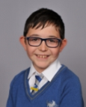
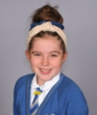

Our Next Steps
I’d like more opportunities to learn about Geography, capital cities and countries around the world.

