Term |  |  | Autumn |  |  |  |  |  |  | Spring |  |  |  |  |  |  | Summer
Year 1 & 2 Cycle A | Main |  | 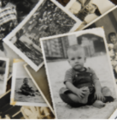  Childhood  History |  |  |  |  |  |  | 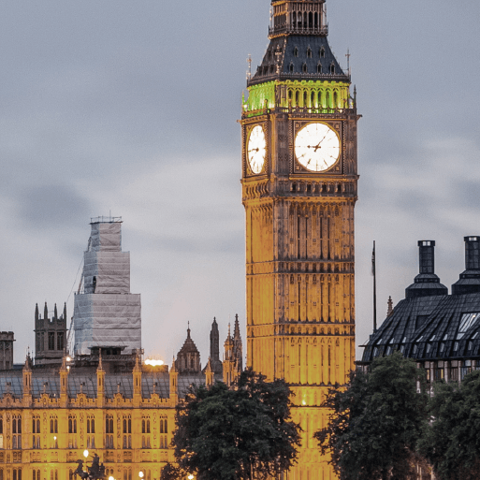  Bright Lights, Big City  Geography |  |  |  |  |  |  | 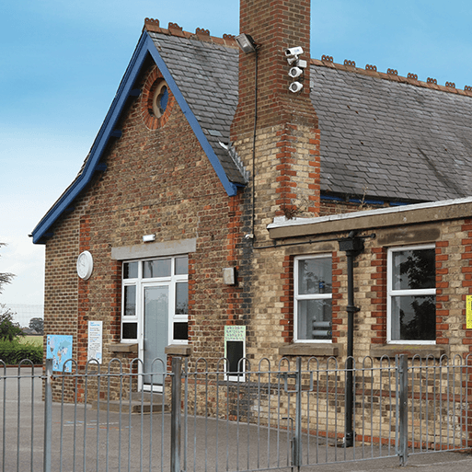  School Days  Geography
 | Memorable Experience |  | Preston Park Museum Visit |  |  |  |  |  |  | Royal Garden Party |  |  |  |  |  |  | Our School’s History
 | English pack genres |  | Autobiographies |  | Non-Chronological Reports |  |  | Riddles |  | Information posters |  | Directions |  |  | Narratives |  | List poems | Diaries |  |  |  | Letters
 | Book study |  | Wilfrid Gordon McDonald Partridge |  |  |  |  |  |  | Topsy and Tim Visit London |  |  |  |  |  |  | Whiffy Wilson: The Wolf who wouldn’t go to school
 | Companion projects | Science | Everyday Materials |  |  | Human Senses |  |  |  | Seasonal Changes |  |  |  |  |  |  | Plant Parts |  |  | Animal Parts
 |  | Art | Mix It (Y1) |  |  | Funny Faces and Fabulous Features |  |  |  | Rain and Sunrays |  |  |  |  |  |  | Street View
 |  | Artist | Wassily Kandinsky, Piet Mondrian |  |  | Portraits |  |  |  | Amanda Snyder |  |  |  |  |  |  | James Rizzi
 |  | DT | Shade and Shelter |  |  |  |  |  |  | Taxi |  |  |  |  |  |  | Chop, Slice, Mash
 |  | History | Childhood: Past & Present |  |  |  |  |  |  | Great Fire of London |  |  |  |  |  |  | Present day schools; Our school; Victorian era; Victorian schools
 |  | Geog | Our Wonderful World |  |  |  |  |  |  | Countries and capital cities of the UK |  |  |  |  |  |  | Fieldwork; Maps; Local environment
 |  | Maths | Autumn White Rose Maths |  |  |  |  |  |  | Spring White Rose Maths |  |  |  |  |  |  | Summer White Rose Maths
 |  | GG | 1 No Poverty  4 Quality Education |  |  |  |  |  |  | 11 Sustainable Cities and Communities  15 Life on Land |  |  |  |  |  |  | 3 Good Health & Wellbeing  10 Reduced Inequalities
 |  | Great Dream | G Giving, R Relating  E Exercise, A Awareness |  |  |  |  |  |  | T. Trying Out  D. Direction, R Resilience |  |  |  |  |  |  | E Emotions  A- Acceptance & M Meaning
 |  | RE | Why is the Qur’an a sacred book?  Why do Christians celebrate Christmas? |  |  |  |  |  |  | The Guru Granth Sahib: A living guru  Why do Christians remember The Last Supper? |  |  |  |  |  |  | Guru Nanak: an extraordinary life  The Torah: God’s Law for the Jews
 |  | Music | Hey You; Christmas Production |  |  |  |  |  |  | In the Groove; Round and Round |  |  |  |  |  |  | Your imagination; Reflect, Rewind and Replay
 |  | PE | Exploring movement (locomotion) |  |  |  |  |  |  | Ball Skills (feet)  Ball skills (hands 1) |  |  |  |  |  |  | Games  Team Building
 |  | PE | Gymnastics |  |  |  |  |  |  | Dance |  |  |  |  |  |  | Ball Skills (Hands 2)  Health and Wellbeing
 |  | MFL | N/A |  |  |  |  |  |  | N/A |  |  |  |  |  |  | N/A
 |  | PSHE | Relationships |  |  |  |  |  |  | Living in the Wider World |  |  |  |  |  |  | Health and Wellbeing
 |  | Computing | Digital Literacy – IT around us  Information technology – Digital photography |  |  |  |  |  |  | Information Technology – Making music  Information Technology – Pictograms |  |  |  |  |  |  | Computer Science – Robot algorithms  Computer Science – Introduction to quizzes
Term |  |  | Autumn |  |  |  |  |  |  | Spring |  |  |  |  |  |  | Summer
Year 1 & 2 Cycle B | Main |  | 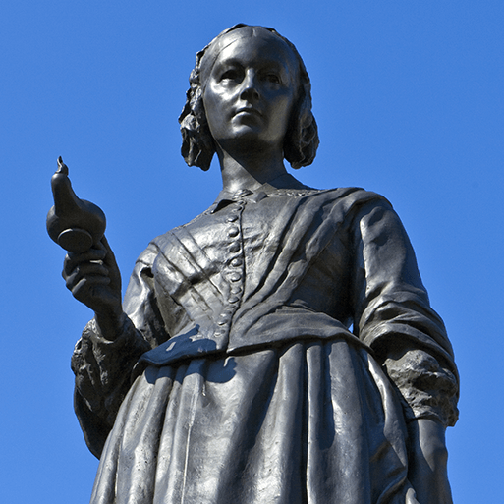  Movers and Shakers  History |  |  |  |  |  |  | 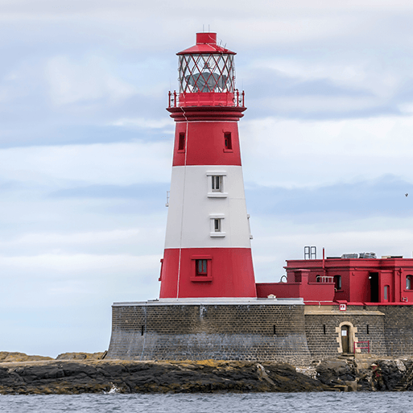  Coastline  Geography |  |  |  |  |  |  | 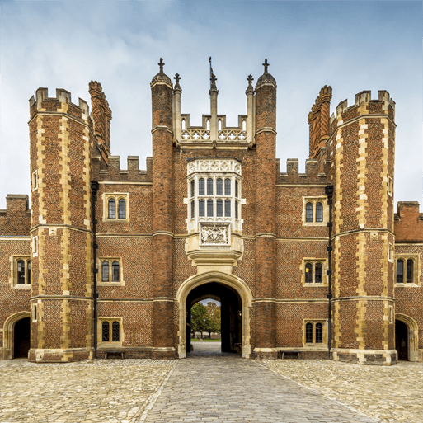  Magnificent Monarchs  Geography
 | Memorable Experience |  | Local Historically Significant Person |  |  |  |  |  |  | Coastal Visit |  |  |  |  |  |  | Castle Visit/Timelines
 | English pack genres |  | Biographies | Newspaper reports |  | Posters |  |  | Speeches | Descriptions | Adventure narratives |  |  | Non-chronological reports |  | Persuasive writing | Information leaflets |  | Kennings poems |  | Comic strips
 | Book study |  | Rosa Parks |  |  |  |  |  |  | Katie Morag and the New Pier |  |  |  |  |  |  | Queen Victoria’s Bathing Machine
 | Companion projects | Science | Human Survival |  |  |  | Habitats |  |  | Uses of Materials |  |  | Plant Survival |  |  |  | Animal Survival
 |  | Art | Mix it |  |  |  | Still life |  |  | Flower Head |  |  |  |  |  |  | Portraits and Poses
 |  | Artist | Wassily Kandinsky, Piet Mondrian |  |  |  | Paul Cezanne |  |  | Vincent Van Gogh |  |  |  |  |  |  | William Scrots, George Gower
 |  | DT | Remarkable Recipes |  |  |  |  |  |  | Beach Hut |  |  |  |  |  |  | Cut, Stitch and Join |  |  | Push and Pull
 |  | History | Historically Significant People |  |  |  |  |  |  | Significant People – Captain Cook |  |  |  |  |  |  | Significant Royals
 |  | Geog | Let's explore the world |  |  |  |  |  |  | World Seas and Oceans |  |  |  |  |  |  | Significant Places – Royal Residences
 |  | Maths | Autumn White Rose Maths |  |  |  |  |  |  | Spring White Rose Maths |  |  |  |  |  |  | Summer White Rose Maths
 |  | GG | 5 Gender Equality  10 Reduced Inequalities |  |  |  |  |  |  | 6 Clean Water and Sanitation  14 Life below Water |  |  |  |  |  |  | 10 Reduced Inequalities  16 Peace, Justice and Strong Institutions
 |  | Great Dream | G Giving, R Relating  E Exercise, A Awareness |  |  |  |  |  |  | T. Trying Out  D. Direction, R Resilience |  |  |  |  |  |  | E – Emotions  A - Acceptance & M Meaning
 |  | RE | How is someone welcomed into Christianity?  Why do Christians give gifts at Christmas? |  |  |  |  |  |  | Belonging to the Muslim Family  What do Christians remember at Easter? |  |  |  |  |  |  | A Man called Mohammed  Belonging to the Sikh Family
 |  | Music | Hands, Feet, Heart; Christmas Production |  |  |  |  |  |  | I Wanna Play in a Band; Zootime |  |  |  |  |  |  | Friendship Song; Reflect, Rewind and Replay
 |  | PE | Exploring movement (locomotion) |  |  |  |  |  |  | Ball Skills (feet)  Ball skills (hands 1) |  |  |  |  |  |  | Games  Team Building
 |  | PE | Gymnastics |  |  |  |  |  |  | Dance |  |  |  |  |  |  | Ball Skills (Hands 2)  Health and Wellbeing
 |  | MFL | N/A |  |  |  |  |  |  | N/A |  |  |  |  |  |  | N/A
 |  | PSHE | Relationships |  |  |  |  |  |  | Living in the Wider World |  |  |  |  |  |  | Health and Wellbeing; Team Building
 |  | Computing | Digital Literacy – Technology Around Us  Information Technology – Digital Painting |  |  |  |  |  |  | Information Technology – Digital Writing  Information Technology – Grouping data |  |  |  |  |  |  | Computer Science – Moving a robot  Computer Science – Introduction to animation

