Term |  |  | Autumn |  |  |  |  |  |  | Spring |  |  |  |  | Summer
Year 3 & 4 Cycle A | Main |  | 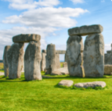  Through The Ages  History |  |  |  |  |  |  | 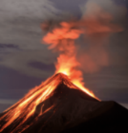  Rock, Relics and Rumbles  Geography |  |  |  |  | 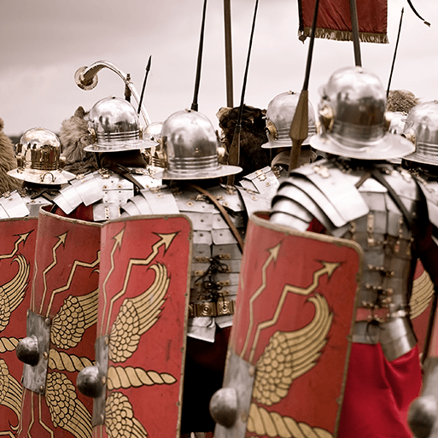  Emperors and Empires  History
 | Memorable Experience |  | Prehistoric Visit/Prehistoric Research |  |  |  |  |  |  | Visit from Geologist/ Rock Presentation |  |  |  |  | Living Museum Visit/Create a museum
 | English pack genres |  | Narratives | Instructions |  | Cinquains |  |  | Chronological Reports | Non-chronological reports | Shape poems |  | Newspaper reports | Diaries | Biographies | Letters |  | Myths |  | Poems
 | Novel study |  | Stig of the Dump |  |  |  |  |  |  | The Firework-Maker’s Daughter |  |  |  |  | Roman Tales: The Goose Guards
 | Companion projects | Science | Skeletal & Muscular Systems |  |  |  |  |  |  | Forces and Magnets |  |  |  |  | Light & Shadows |  |  | Plant Nutrition & Reproduction
 |  | Art | Contrast & Complement |  |  | Prehistoric Pots |  |  |  | Ammonite |  | People and Places |  |  | Beautiful Botanicals |  |  | Mosaic Masters
 |  | Artist | Henry Matisse, Pablo Picasso |  |  | Bell Beaker Pottery |  |  |  | Fibonacci Patterns |  | LS Lowry |  |  | Katie Scott |  |  | Roman mosaics
 |  | DT | Cook Well, Eat Well |  |  |  |  |  |  | Making It Move |  |  |  |  | Greenhouse
 |  | History | British prehistory - Stone Age to the Iron Age |  |  |  |  |  |  | Significant people – Mary Anning; Pompeii |  |  |  |  | The Romans
 |  | Geog | One Planet, Our World |  |  |  |  |  |  | Layers of the Earth; Rocks; Plate tectonics |  |  |  |  | Maps
 |  | Maths | Autumn White Rose Maths |  |  |  |  |  |  | Spring White Rose Maths |  |  |  |  | Summer White Rose Maths
 |  | GG | 2 Zero Hunger  15 Life on Land |  |  |  |  |  |  | 7 Affordable and Clean Energy  13 Climate Action |  |  |  |  | 9 Industry, Innovation and Infrastructure  10 Reduced Inequalities
 |  | Great Dream | G Giving, R Relating  E Exercise, A Awareness |  |  |  |  |  |  | T. Trying Out  D. Direction, R Resilience |  |  |  |  | E – Emotions  A - Acceptance & M Meaning
 |  | RE | Judaism: Believing & Belonging  Why is Christmas a Winter Festival? |  |  |  |  |  |  | Why did Monks copy The Gospels by hand?  Why is Easter a Spring Festival? |  |  |  |  | What is Eid?  What is a Mosque for?
 |  | Music | Glockenspiel 1 & 2 |  |  |  |  |  |  | Three Little Birds  Easter Production |  |  |  |  | The Dragon Song  Reflect, Rewind & Replay
 |  | PE | Gymnastics  Dance |  |  |  |  |  |  | Invasion Games: Football  Invasion Games: Hockey |  |  |  |  | Net/Wall Games: Tennis  Athletics
 |  | PE | Invasion Games: Tag Rugby  Invasion Games: Netball |  |  |  |  |  |  | Invasion Games: Basketball  Invasion Games: Handball |  |  |  |  | Outdoor Adventurous Activity  Rounders
 |  | MFL | Phonics 1&2;Presenting Myself;  In the Classroom |  |  |  |  |  |  | Ancient Britain;  Fruit & Vegetables |  |  |  |  | Little Red Riding Hood  At the Café
 |  | PSHE | Relationships; Living in the Wider World |  |  |  |  |  |  | Living in the Wider World  Health & Wellbeing |  |  |  |  | Health & Wellbeing
 |  | Computing | Digital Literacy – The Internet  Information Technology – Audio Editing |  |  |  |  |  |  | Information Technology – Photo Editing  Information Technology – Data Logging |  |  |  |  | Computer Science – Repetition in Games
Term |  |  | Autumn |  |  |  |  |  |  | Spring |  |  |  |  | Summer
Year 3 & 4 Cycle B | Main |  | 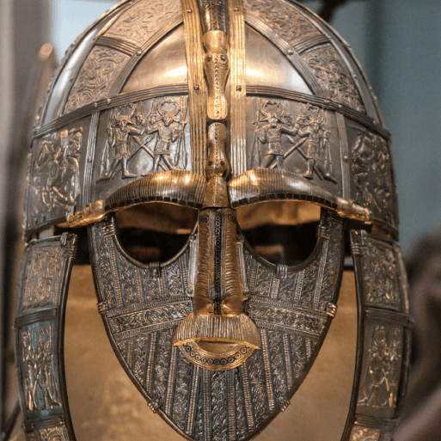  Invasion  History |  |  |  |  |  |  | 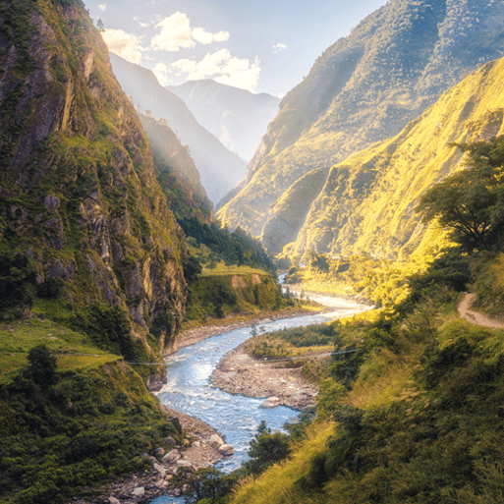  Misty Mountain, Winding River  Geography |  |  |  |  | 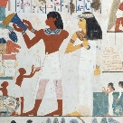  Ancient Civilisations  History
 | Memorable Experience |  | ‘The Ruin’ Study |  |  |  |  |  |  | River Tees Visit/Study |  |  |  |  | Archaelogical Finds
 | English pack genres |  | Anglo-Saxon poems |  | Playscripts | Norse myths |  | Non-chronological reports |  | Diaries | Leaflets |  | Explanations | Narrative poems | Free verse poems |  | Instructions |  | Stories from other cultures
 | Novel study |  | The Saga of Erik the Viking |  |  |  |  |  |  | King of the Cloud Forests |  |  |  |  | Secrets of a Sun King
 | Companion projects | Science | Digestive System |  |  |  |  |  |  | States of Matter |  |  |  |  | Electrical Circuits & Conductors
 |  | Art | Contrast and Complement |  |  |  | Warp and Weft |  |  | Vista |  | Animal |  |  | Statues, Statuettes and Figurines |  |  | Islamic Art
 |  | Artist |  |  |  |  |  |  |  | Landscape Artists |  | Bankura horses of Panchmura |  |  | Sumer Style Figurine
 |  | DT | Fresh Food, Good Food |  |  |  |  |  |  | Functional and Fancy Fabrics |  |  |  |  | Tomb Builders
 |  | History | Anglo Saxon; Viking |  |  |  |  |  |  |  |  |  |  |  | Ancient Sumer; Ancient Egypt
 |  | Geog | Interconnected World |  |  |  |  |  |  | Rivers; Mountains; Water Cycle
 |  | Maths | Autumn White Rose Maths |  |  |  |  |  |  | Spring White Rose Maths |  |  |  |  | Summer White Rose Maths
 |  | GG | 2 Zero Hunger  9 Industry, Innovation and Infrastructure |  |  |  |  |  |  | 13 Climate Action  14 Life Below Water |  |  |  |  | 3 Good Health & Wellbeing  11 Sustainable Cities & Communities
 |  | Great Dream | G Giving, R Relating  E Exercise, A Awareness |  |  |  |  |  |  | T. Trying Out  D. Direction, R Resilience |  |  |  |  | E – Emotions  A - Acceptance & M Meaning
 |  | RE | Diwali, Hinduism & Sikhism  What is the ‘Big Story’ of Christmas? |  |  |  |  |  |  | Do all Buddhists believe and celebrate the same thing?  What actually happens at Easter? |  |  |  |  | Muslims in Britain and Around the World
 |  | Music | Mamma Mia! Stop! |  |  |  |  |  |  | Lean on Me; Easter Production |  |  |  |  | Bringing Us Together; Reflect, Rewind & Replay
 |  | PE | Gymnastics  Dance |  |  |  |  |  |  | Invasion Games: Football  Invasion Games: Hockey |  |  |  |  | Net/Wall Games: Tennis  Athletics
 |  | PE | Invasion Games: Tag Rugby  Invasion Games: Netball |  |  |  |  |  |  | Invasion Games: Basketball  Invasion Games: Handball |  |  |  |  | Outdoor Adventurous Activity  Rounders
 |  | MFL | Phonics 1 & 2; Seasons KS2  Musical Instruments |  |  |  |  |  |  | Vegetables  I can |  |  |  |  | Habitat  Goldilocks
 |  | PSHE | Relationships; Living in the Wider World |  |  |  |  |  |  | Relationships; Living in the Wider World |  |  |  |  | Health and Wellbeing
 |  | Computing | Digital Literacy – Connecting Computers  Information Technology - Animation |  |  |  |  |  |  | Information Technology – Desktop Publishing |  |  |  |  | Computer Science – Sequence in Music  Computer Science – Events and actions

