Term |  |  | Autumn |  |  |  |  |  |  | Spring |  |  |  |  | Summer
Year 5 & 6 Cycle A | Main |  | 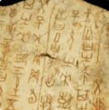  Dynamic Dynasties  History |  |  |  |  |  |  | 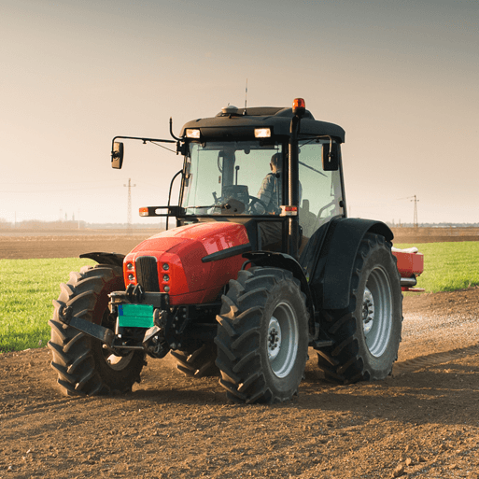  Sow, Grow and Farm  Geography |  |  |  |  | 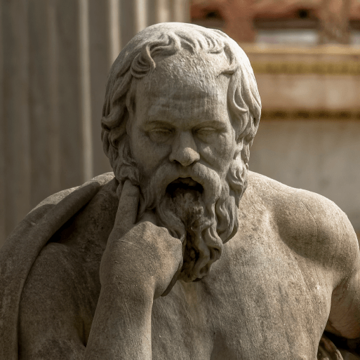  Groundbreaking Greeks  History
 | Memorable Experience |  | The Yellow Emperor and the Xia Dynasty |  |  |  |  |  |  | Allotment Visit/ Study |  |  |  |  | Time Teams
 | English pack genres |  | Narrative Poems |  | Biographies |  |  | Stories from Other Cultures |  | Non-chronological reports | Diaries |  | Leaflets | Balanced arguments | Greek myths | Balanced arguments |  | Playscripts |  |  | Odes
 | Novel study |  | Bronze and Sunflower |  |  |  |  |  |  | The Secret Garden |  |  |  |  | Who Let the Gods Out?
 | Companion projects | Science | Forces & Mechanisms |  |  | Earth & Space |  |  |  | Human Reproduction & Aging |  |  |  |  | Properties and Changes of Materials
 |  | Art | Tints, Tones and Shades (Y5) |  |  | Taotie |  |  |  | Light, Line and Shadow |  | Nature's Art |  |  | Mixed Media |  |  |  | Expression
 |  | Artist | Landscape Artists |  |  | Make Taotie Pieces |  |  |  | Pablo Picasso, Rembrandt |  | Robert Smithson, Richard Long, Rebecca Law |  |  | Not Yet Available |  |  |  | Not Yet Available
 |  | DT | Moving Mechanisms |  |  |  |  |  |  | Eat the Seasons |  |  |  |  | Architecture
 |  | History | Ancient China; Shang Dynasty |  |  |  |  |  |  | Dig for Victory |  |  |  |  | Ancient Greek Periods
 |  | Geog | Investigating Our World |  |  |  |  |  |  | Farming in the UK; Farming around the World |  |  |  |  | Interpreting geographical sources
 |  | Maths | Autumn White Rose Maths |  |  |  |  |  |  | Spring White Rose Maths |  |  |  |  | Summer White Rose Maths
 |  | GG | 8 Decent Work and Economic Growth  9 Industry, Innovation and Infrastructure |  |  |  |  |  |  | 7 Affordable and Clean Energy  15 Life on Land |  |  |  |  | 9 Industry, Innovation and Infrastructure  11 Sustainable Cities & Communities
 |  | Great Dream | G Giving, R Relating  E Exercise, A Awareness |  |  |  |  |  |  | T. Trying Out  D. Direction, R Resilience |  |  |  |  | E – Emotions  A - Acceptance & M Meaning
 |  | RE | Sikhism – The Gurdwara  Is Christmas too Commercial? |  |  |  |  |  |  | Who is responsible for Jesus’ death? |  |  |  |  | Is faith always the same?  What does art tell us?
 |  | Music | Livin on a Prayer; Classroom Jazz 1 |  |  |  |  |  |  | Classroom Jazz 2; Make You Feel My Love |  |  |  |  | Fresh Prince; Reflect, Rewind and Replay
 |  | PE | Gymnastics  Dance |  |  |  |  |  |  | Invasion Games: Football  Invasion Games: Hockey |  |  |  |  | Net/Wall Games: Tennis  Athletics
 |  | PE | Invasion Games: Tag Rugby  Invasion Games: Netball |  |  |  |  |  |  | Invasion Games; Basketball  Outdoor Adventurous Activity |  |  |  |  | Rounders  Cricket
 |  | MFL | Phonics Lesson 1 & 2; At School  Healthy Lifestyle |  |  |  |  |  |  | Family  Pets |  |  |  |  | Olympics  At the Weekend
 |  | PSHE | Living in the Wider World;  Health and Wellbeing |  |  |  |  |  |  | Relationships |  |  |  |  | Relationships; Living in the Wider World
 |  | Computing | Digital Literacy – Communication  Information Technology – 3D modelling |  |  |  |  |  |  | Information Technology – Web page creation; Spreadsheets |  |  |  |  | Computer Science – Selection in physical computing; Sensing
Term |  |  | Autumn |  |  |  |  |  |  | Spring |  |  |  |  | Summer
Year 5 & 6 Cycle B | Main |  | 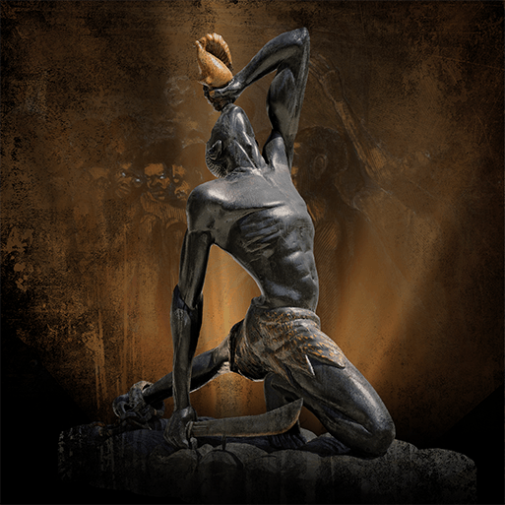  Maafa  History |  |  |  |  |  |  | 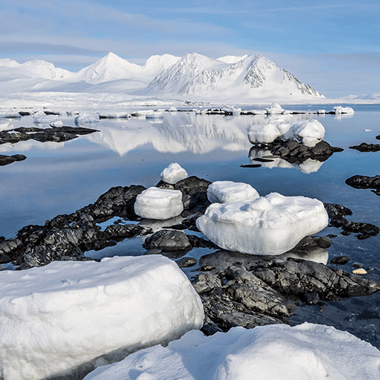  Frozen Kingdoms  Geography |  |  |  |  | 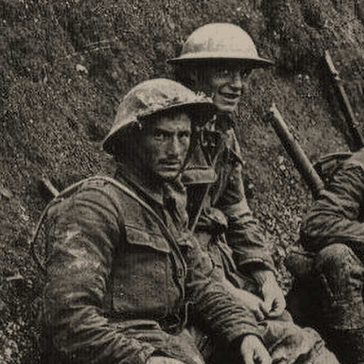  Britain at War  History
 | Memorable Experience |  | Welcome to Africa |  |  |  |  |  |  | Polar Expedition/Study |  |  |  |  | War Museum Visit/Study
 | English pack genres |  | Newspaper reports | Persuasive letters |  | Non-chronological reports |  |  | Acrostic poems | Non-chronological reports | Haikus |  | Newspaper reports | Adventure narratives | Persuasive posters |  | Historical narratives |  |  | Nonets
 | Novel study |  | Freedom |  |  |  |  |  |  | The Wolf Wilder |  |  |  |  | Goodnight Mister Tom
 | Companion projects | Science | Circulatory System |  |  |  |  |  |  | Electrical Circuits & Components |  |  |  |  | Evolution and Inheritance |  |  |  | Light Theory
 |  | Art | Tints, Tones and Shades (Y6) |  |  |  | Trailblazers, Barrier Breakers |  |  | Inuit |  | Environmental Artists |  |  | Distortion and Abstraction |  |  |  | Bees, Beetles and Butterflies
 |  | Artist | Landscape Artists |  |  |  | Significant Black Artists |  |  | Significant Inuit Artists |  | Significant Environmental Artists |  |  | Not Yet Available |  |  |  | Not Yet Available
 |  | DT | Food for Life |  |  |  |  |  |  | Engineer |  |  |  |  | Make Do and Mend
 |  | History | Ancient African kingdoms; Britain’s role in the Slave Trade |  |  |  |  |  |  | Polar exploration; Significant people – Robert Falcon Scott; Ernest Shackleton; Significant events – Titanic |  |  |  |  | First and Second World Wars
 |  | Geog | Our Changing World |  |  |  |  |  |  | Arctic and Antarctic regions; Polar climates |  |  |  |  | Place and interconnections; Maps
 |  | Maths | Autumn White Rose Maths |  |  |  |  |  |  | Spring White Rose Maths |  |  |  |  | Summer White Rose Maths
 |  | GG | 1 No Poverty  2 Zero Hunger |  |  |  |  |  |  | 13 Climate Action  14 Life Below Water |  |  |  |  | 3 Good Health & Wellbeing  12 Responsible Consumption and Production
 |  | Great Dream | G Giving, R Relating  E Exercise, A Awareness |  |  |  |  |  |  | T. Trying Out  D. Direction, R Resilience |  |  |  |  | E – Emotions  A - Acceptance & M Meaning
 |  | RE | From life to death, what role does religion play?  Why are the gospel accounts different? |  |  |  |  |  |  | Food & Drink:What are religious rules for?  Why is Jesus’ death seen as a victory? |  |  |  |  | What is Worship? What is it for?
 |  | Music | Happy; Dancing in the Street |  |  |  |  |  |  | A New Year Carol; You’ve Got a Friend |  |  |  |  | Music and Me; Reflect, Rewind and Replay
 |  | PE | Gymnastics  Dance |  |  |  |  |  |  | Invasion Games: Football  Invasion Games: Hockey |  |  |  |  | Net/Wall Games: Tennis  Athletics
 |  | PE | Invasion Games: Tag Rugby  Invasion Games: Netball |  |  |  |  |  |  | Invasion Games; Basketball  Outdoor Adventurous Activity |  |  |  |  | Rounders  Cricket
 |  | MFL | Phonics Lesson 3 & 4; The Date; My Home |  |  |  |  |  |  | Clothes; Planets |  |  |  |  | Me in the World; Regular Verbs
 |  | PSHE | Living in the Wider World; Health and Wellbeing; Relationships |  |  |  |  |  |  | Living in the Wider World  Relationships |  |  |  |  | Living in the Wider World
 |  | Computing | Digital Literacy – Sharing Information  Information technology – Vector Drawing |  |  |  |  |  |  | Information Technology – Video Editing; Flat file databases |  |  |  |  | Computer Science – Variables in games  Computer Science – Selection in Quizzes

