**Science Monitoring 2022 Reception** Spring Term

**Progress in science:**

We know about ducks. We know that they can swim because we have seen them swim in Reception!

Babies live in eggs.

**We learn new skills:**

When we looked at leaves we learned about autumn and how the leaves turn orange.

Ducks have webbed feet to help them paddle faster so predators don’t eat them!

Ducks lay eggs and the ducklings hatch themselves. They drink water and eat duck food. There was a brown one and a yellow one!

**Pupil Voice**

**What we are learning:**

Science is magnets. I’ve got some at home and you can push or pull depending on which way you want to go. We held the ducklings and learned about ducks.

We have learned about rainbows.

**Our thoughts about Science:**

We like it because it helps us learn about animals. It helps us learn new things.

**Our Next Steps:**

Learn more.

Learn about different animals.

Learn about dinosaurs.

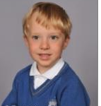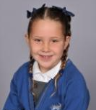

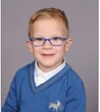

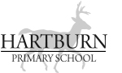

**Book Look**

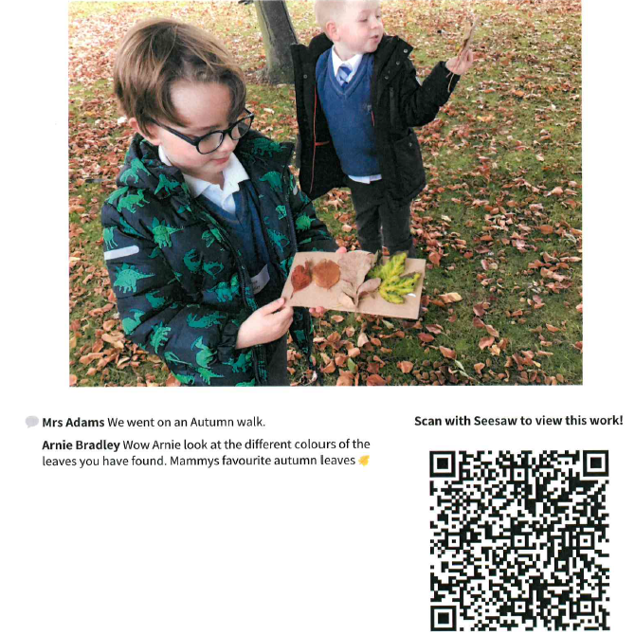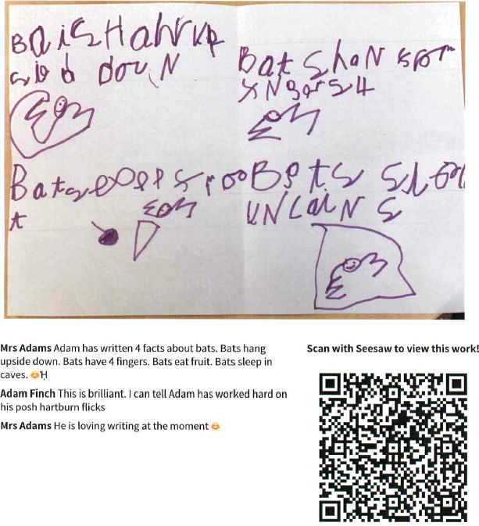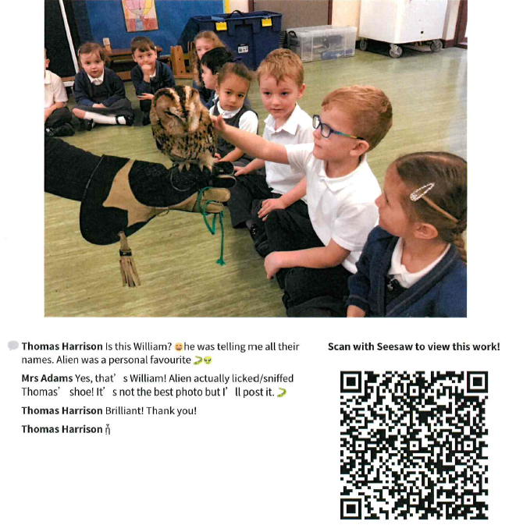

**Strengths:**

* Children have a very good understanding of what science means.
* Children are very engaged and enthusiastic about science.

**Next steps:**

* Continue to develop opportunities for real-life, practical experiences, e.g. different animal visitors.