**Science Monitoring 2022 Year 1** Spring Term

**Progress in science:**

We don’t talk in lessons as much in Y1. We have learnt how to draw diagrams to show the different seasons. We now know what bark, leaves, branches and blossom are. The roots help the trees grow because the suck up the water. The leaves take in the sun. We know the buds on trees grow into flowers and we didn’t know that in Reception.

**We learn new skills:**

We were learning about squirrels and how they are born then they get more fluff to keep them warm. Baby squirrels are called kittens. How the trees get leaves and pollen. The leaves come off at autumn. The other trees, the leaves are staying on in winter. When it’s autumn the leaves change to different colours like red, orange and in spring and summer are green.

**Pupil Voice**

**What we are learning:**

We are learning about the weathers.

We are learning about the seasons.

We now know about trees.

**Our thoughts about Science:**

It’s really fun because of the activities. We get to do explosions! It’s where you learn more. You get to make potions and stuff.

**Our Next Steps:**

You need to know loads and loads of things. If you want to learn more, you have to listen to the teacher. No whispering in the lessons when the teacher is talking.

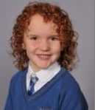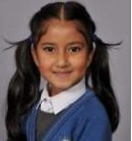

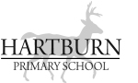

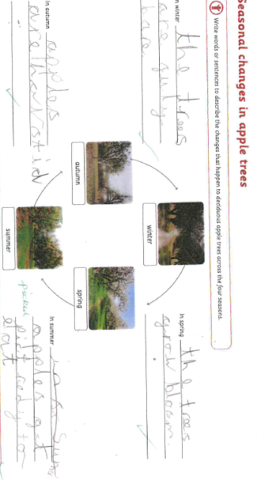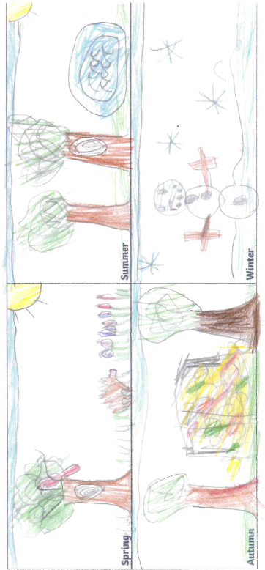**Book Look**

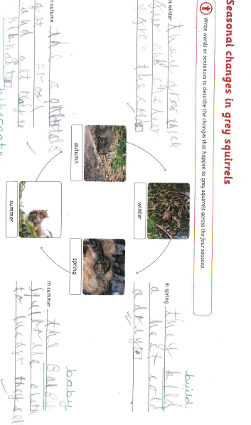

**Strengths:**

* Children demonstrate a good level of understanding of seasonal change in animals and plants.
* Work is well-presented and children are beginning to use scientific age appropriate vocabulary.

**Next steps:**

* Continue to develop further tier 2 and 3 vocabulary in science lessons.
* Continue to verbally label the lesson so that all Y1 children know when they are learning science.