**Science Monitoring 2022 Year 2** Spring Term

**Progress in science:**

I am better at understanding because we know a lot more things and understand it more. We understand more about sun safety and being in the shade. We are better at drawing diagrams and doing more writing. I can use the word compare now. I know about buds and blossom which area the end of the trees which we I didn’t know in Y1. I know about evergreen and deciduous and we went on a walk in Y2 to find them. Evergreen is where it stays green for the whole year like Christmas trees and Monkey tree and deciduous are where the leaves fall off in winter.

**We learn new skills**

To tell when it’s spring, summer, autumn and winter.

How it rains, how it snows and how the sun comes out.

About the sun, about how all the planets move around the sun, it takes 365 days for the Earth to move, the Earth is moving right now but we can’t feel it.

**Pupil Voice**

**What we are learning:**

We have been learning about trees and the weather.

We have been learning about seasons and the order of seasons.

**Our thoughts about Science**

I like how we write and draw things. I like how we experiment and learn more things than we know already. I like when we do investigations because I like to find out what floats and what sinks, we did that once. I like to explore.

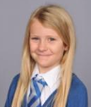

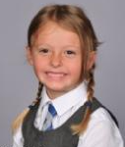

**Our Next Steps**

I think we ned to be even more careful with our work and not rush it so it’s not messy and so it’s neat.

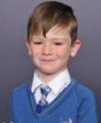



**Book Look**

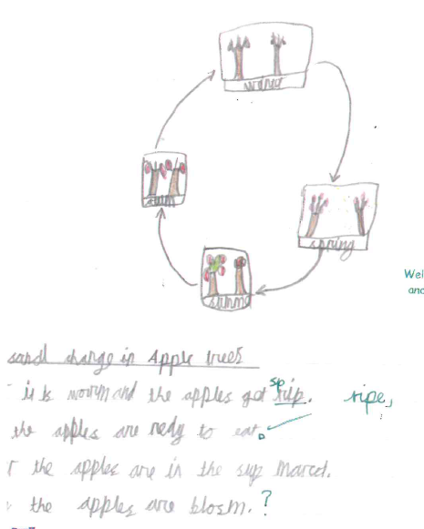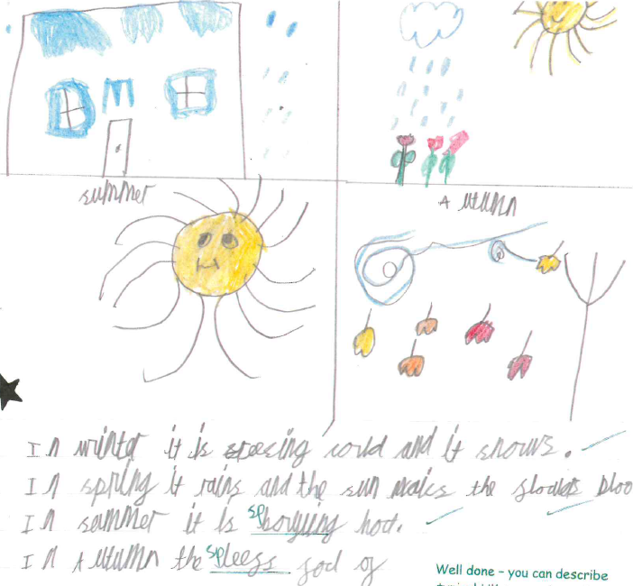

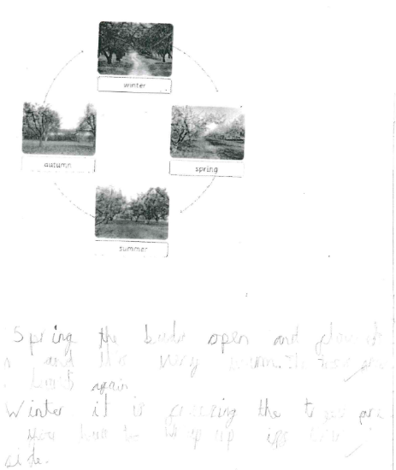

**Strengths:**

* High levels of understanding and engagement as a result of practical investigations which make learning memorable.
* All the children are using age appropriate vocabulary in their writing and verbal explanations.

**Next steps:**

* Continue to develop report writing skills for KS2 readiness for investigations, e.g. use of subheadings.