**Science Monitoring 2022 Year 4** Spring Term

**Progress in Science**

I can explain how the rocks are formed using the correct scientific vocabulary.

I can describe the contact forces of a push and pull force using the correct scientific vocabulary.

**We learn new skills**

I can compare and group together different kinds of rocks based on their appearance and physical properties.

I can describe how fossils are formed.

I can identify the two contacts in a contact force.

**Pupil Voice**

**What we are learning:**

There are three different rock types: sedimentary, igneous and metamorphic.

That some forces need contact between two objects, these are contact forces.

**Our thoughts about Science**

I love science because you get to figure things out by yourself, rather than read it in a book.

I love science because you learn things that you didn’t think were possible, when iron filings show the magnetic forces.

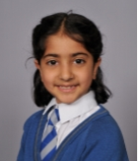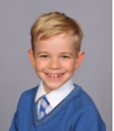

**Our Next Steps**

I’m really looking forward to the soil investigation. I really like forces, I’m looking forward to using the force meters. I’m really looking forward to investigating frictional forces.

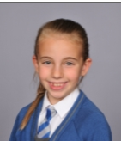



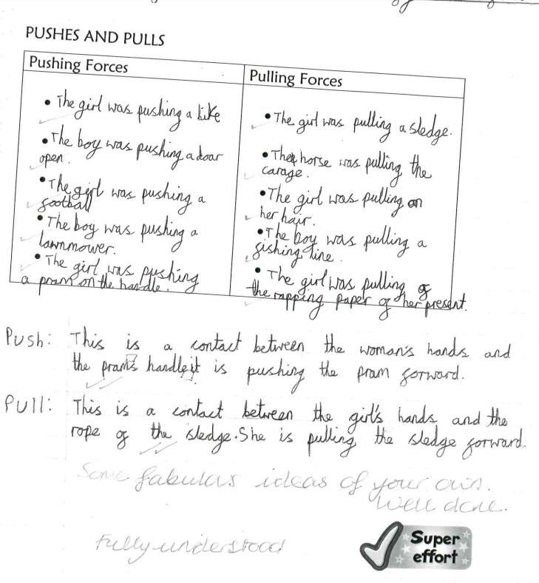**Book Look**

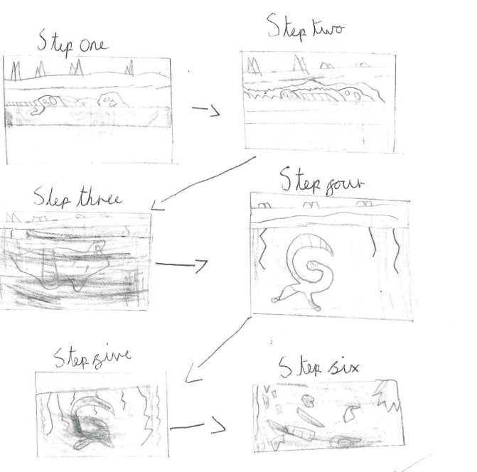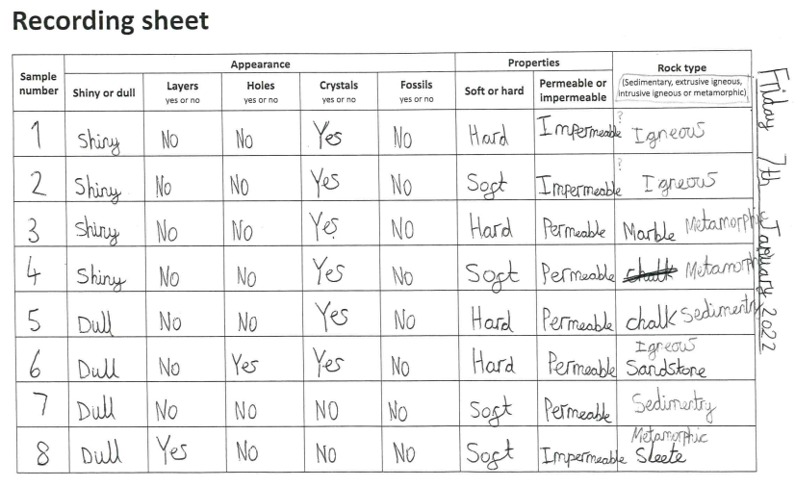

**Strengths:**

* High levels of engagement as a result of practical investigations which make learning memorable.
* All the children are using age appropriate vocabulary in their writing and verbal explanations.

**Next steps:**

* Continue to develop investigational skills, improve recording.