**Science Monitoring 2022 Year 5** Spring Term

**Progress in Science**

I can talk about the life cycle of mammals using the correct scientific vocabulary.

I can describe the life cycle of an asexual plant using the correct scientific vocabulary.

**We learn new skills**

We can describe the changes as humans develop to old age.

We can describe the life process of reproduction in some plants.

**Pupil Voice**

**What we are learning:**

For mammals a life cycle is the series of changes in the life of a living thing and includes embryo, juvenile, adolescent and adult.

Some plants, such as bulbs, corms and rhizomes reproduce asexually.

**Our thoughts about Science**

Science can take you away to a different world.

It’s like an expedition into the unknown.

I like problem solving, when an electrical circuit doesn’t work and you have to work out why and then fix it.

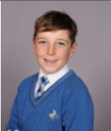

**Our Next Steps**

I’d like more opportunities to do experiments. I’d like a week of Science where we do it every day. I’d like to use my problem solving skills more.

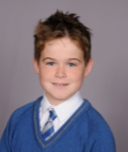



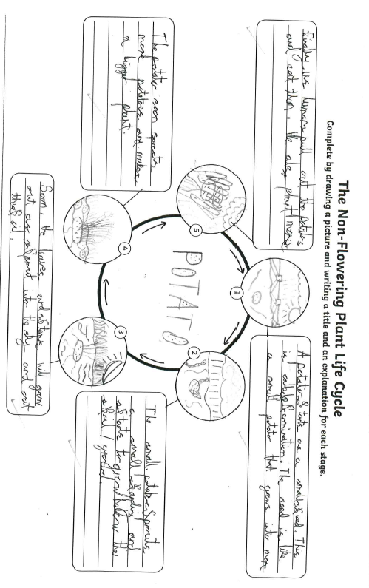**Book Look**

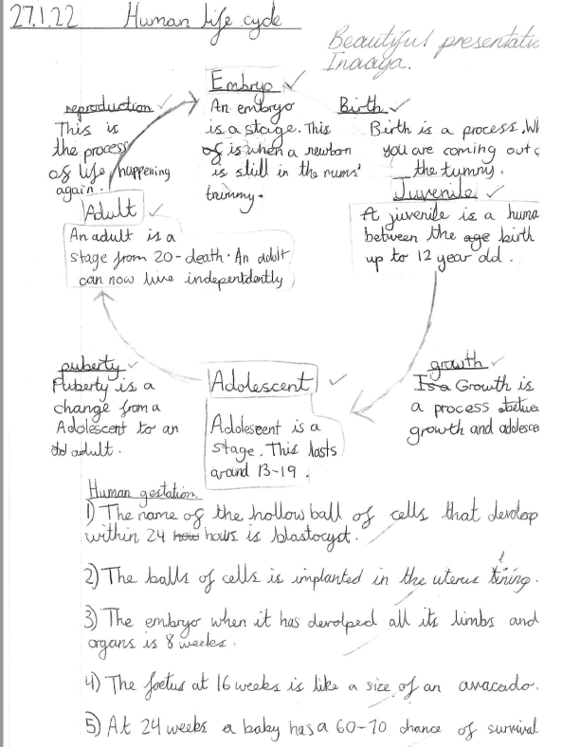

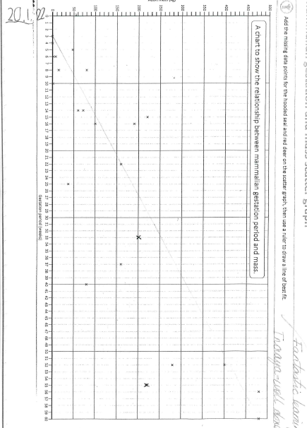

**Strengths:**

* High levels of engagement as a result of practical investigations which make learning memorable.
* All the children are using age appropriate vocabulary in their writing and verbal explanations.

**Next steps:**

* Continue to develop report writing skills for KS3 readiness, e.g. improved layout.