**Science Monitoring 2022 Year 6** Spring Term

**Progress in science:**

We can label different types of plants and know what’s inside the egg and what’s in blood. My knowledge and my understanding of how to do an investigation has improved.

**We learn new skills:**

What you need to solve and what you need to find in the egg. How to solve the problem. We learned how to draw the parts of a flower, like the stigma and the petal. We used subtitles in our science reports. We had to keep the test fair.

**Pupil Voice**

**What we are learning:**

We have been learning about plants and what’s in an egg – the different parts.

We made blood last term!

**Our thoughts about Science:**

I do enjoy science but it’s quite hard sometimes. You get to experience new activities. You get to try new experiments and learn about different animals and plants and what you need to do to make it grow really tall. And how life cycles work. It’s more fun to experiment than to learn about it in a book.

I love doing experiments because it’s so much fun.

**Our Next Steps:**

Read more science books to understand more.

More help to write a conclusion using evidence.

Try new experiments and learn more details about plants and how they grow. Lifecycles so I can improve my understanding and I did really enjoy this part.

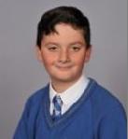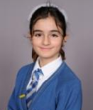

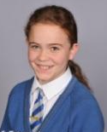



**Book Look**

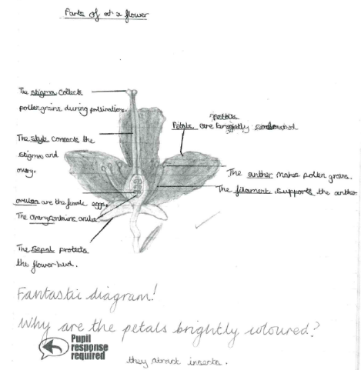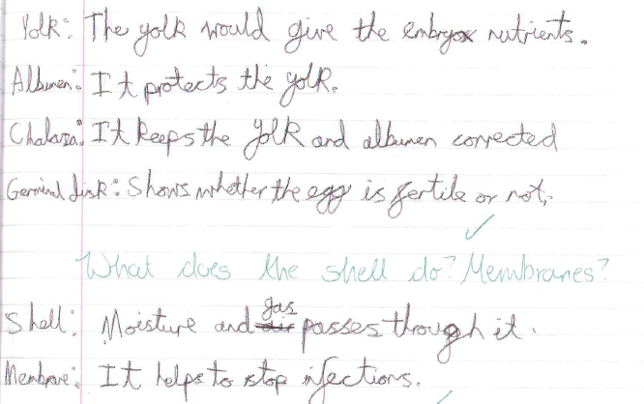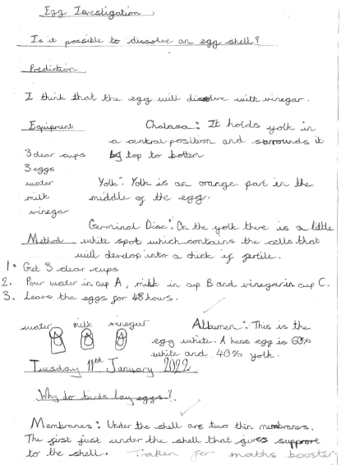 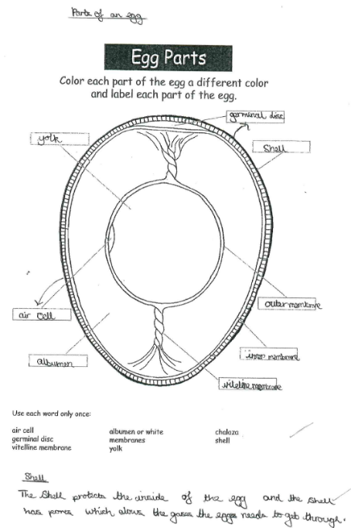

**Strengths:**

* High levels of engagement as a result of practical investigations which make learning memorable.
* All the children are using age appropriate vocabulary in their writing and verbal explanations.

**Next steps:**

* Continue to develop report writing skills for KS3 readiness, e.g. improved layout and more detailed conclusions using evidence from the results.