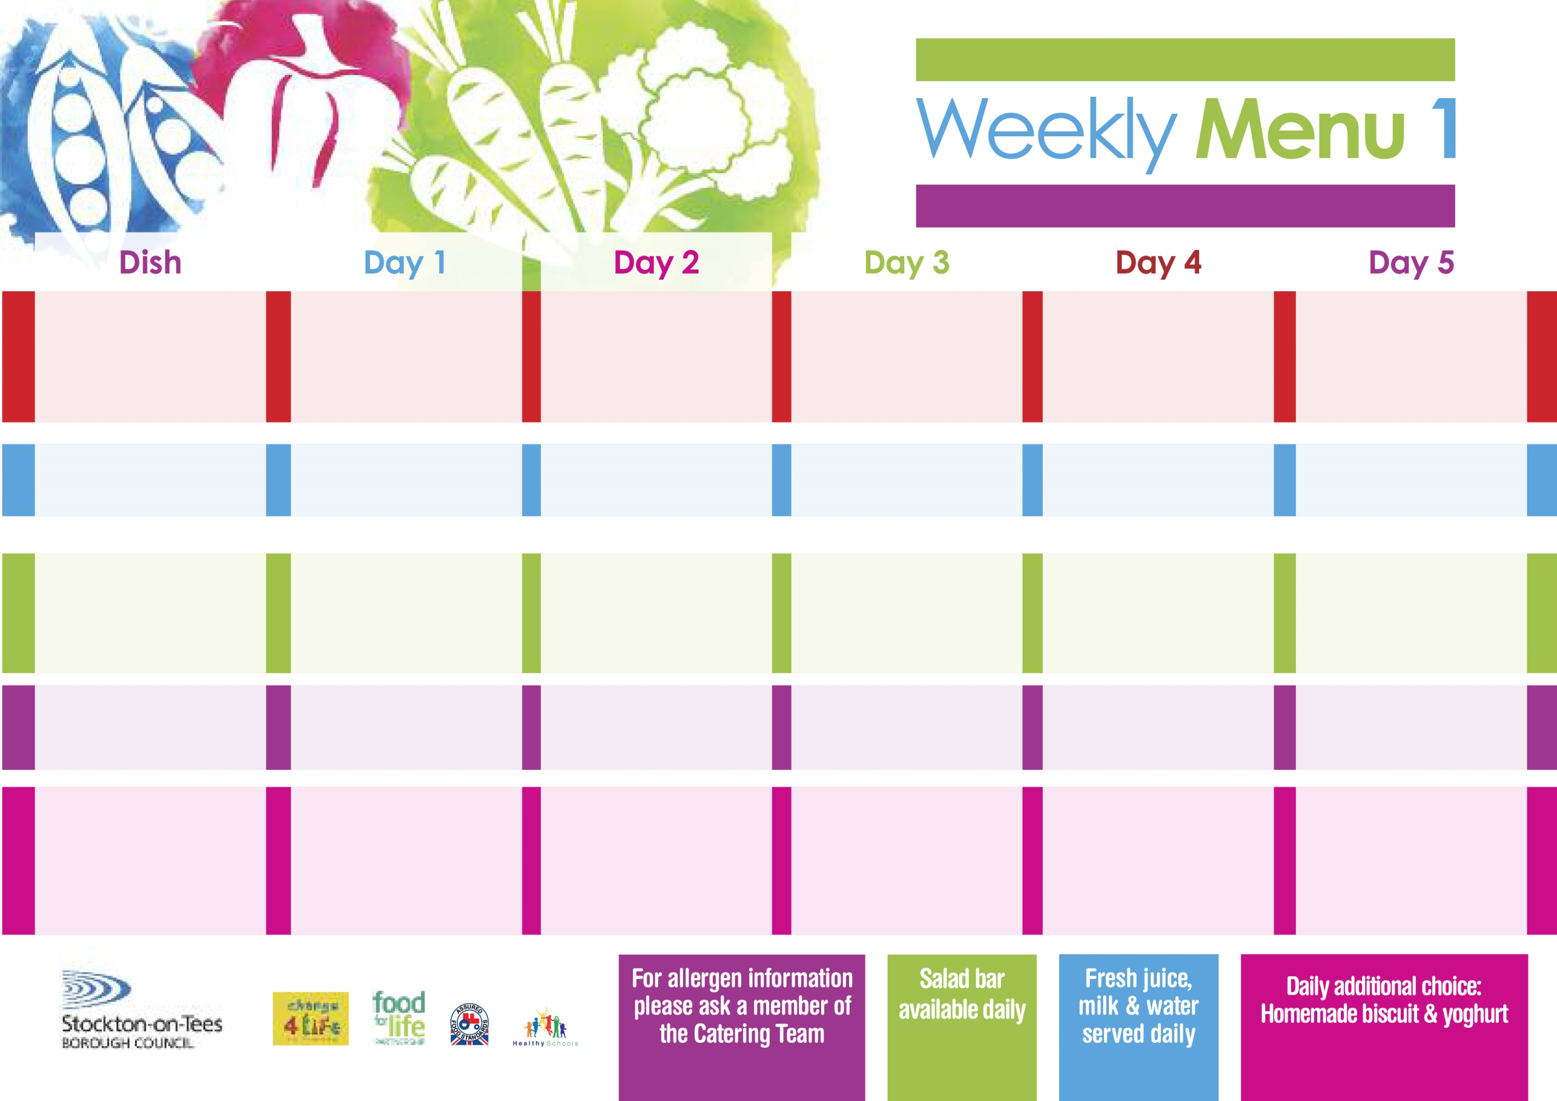

**Mince Beef & Dumpling**

**Baby Boiled Potatoes**

**Diced Swede**

**Garden Peas**

**Quorn Mince & Dumpling**

**(V)**

**Fish Star**

**Baby Boiled Potatoes**

**Baked Beans**

**Garden Peas**

**Cheese Sandwich (V)**

**Baby Boiled Potatoes**

**Chocolate Sponge**

**with Custard Sauce**

**Cold Bar**

**Fresh Fruit Salad**

**Breaded Chicken Breast**

**Oven Roasted Potatoes**

**Spaghetti Hoops**

**Sweetcorn**

**Cheese & Onion Roll (V)**

**Oven Roasted Potatoes**

**Spaghetti Hoops**

**Sweetcorn**

**Ham Sandwich**

**Oven Roasted Potatoes**

**Syrup Roly Poly**

**with Custard Sauce**

**Cold Bar**

**Fresh Fruit Bowl**

**17th April, 15th May, 19th June & 17th July, 2023**

**Pork Pie**

**Creamed Potatoes**

**Mixed Vegetables**

**Cauliflower**

**Penne Pasta in Tomato Sauce (V)**

**Homemade Garlic Bread**

**Cauliflower**

**Mixed Vegetables**

**Tuna Sandwich**

**Baked Jacket Potato**

**Vanilla Sponge**

**with Custard Sauce**

**Cold Bar**

**Fresh Fruit Salad**

**Wristband Primary School Menu**

**+**

**Baked Cumberland Sausages in Gravy**

**Creamed Potatoes**

**Diced Carrots**

**Broccoli**

**Baked Quorn Sausages in Gravy (V)**

**Jacket Potato filled with Tuna, Cheese (V) or Baked Beans (V)**

**Egg Mayonnaise Sandwich**

**(V)**

**Baked Jacket Potatoes**

**Apple Crumble**

**with Custard Sauce**

**Cold Bar**

**Fresh Fruit Bowl**

**Harry Ramsden Fish Fillet**

**Oven Baked Chips**

**Garden Peas**

**Baked Beans**

**Homemade Pizza (V)**

**Oven Baked Chips**

**Garden Peas**

**Baked Beans**

**Egg Mayonnaise Sandwich (V)**

**Oven Baked Chips**

**Creamy Rice Pudding**

**with Jam Sauce**

**Cold Bar**

**Fresh Fruit Bowl**

**Red Choice**

**Blue Choice**

**Green Choice**

**Cold Selection**

**Desserts**