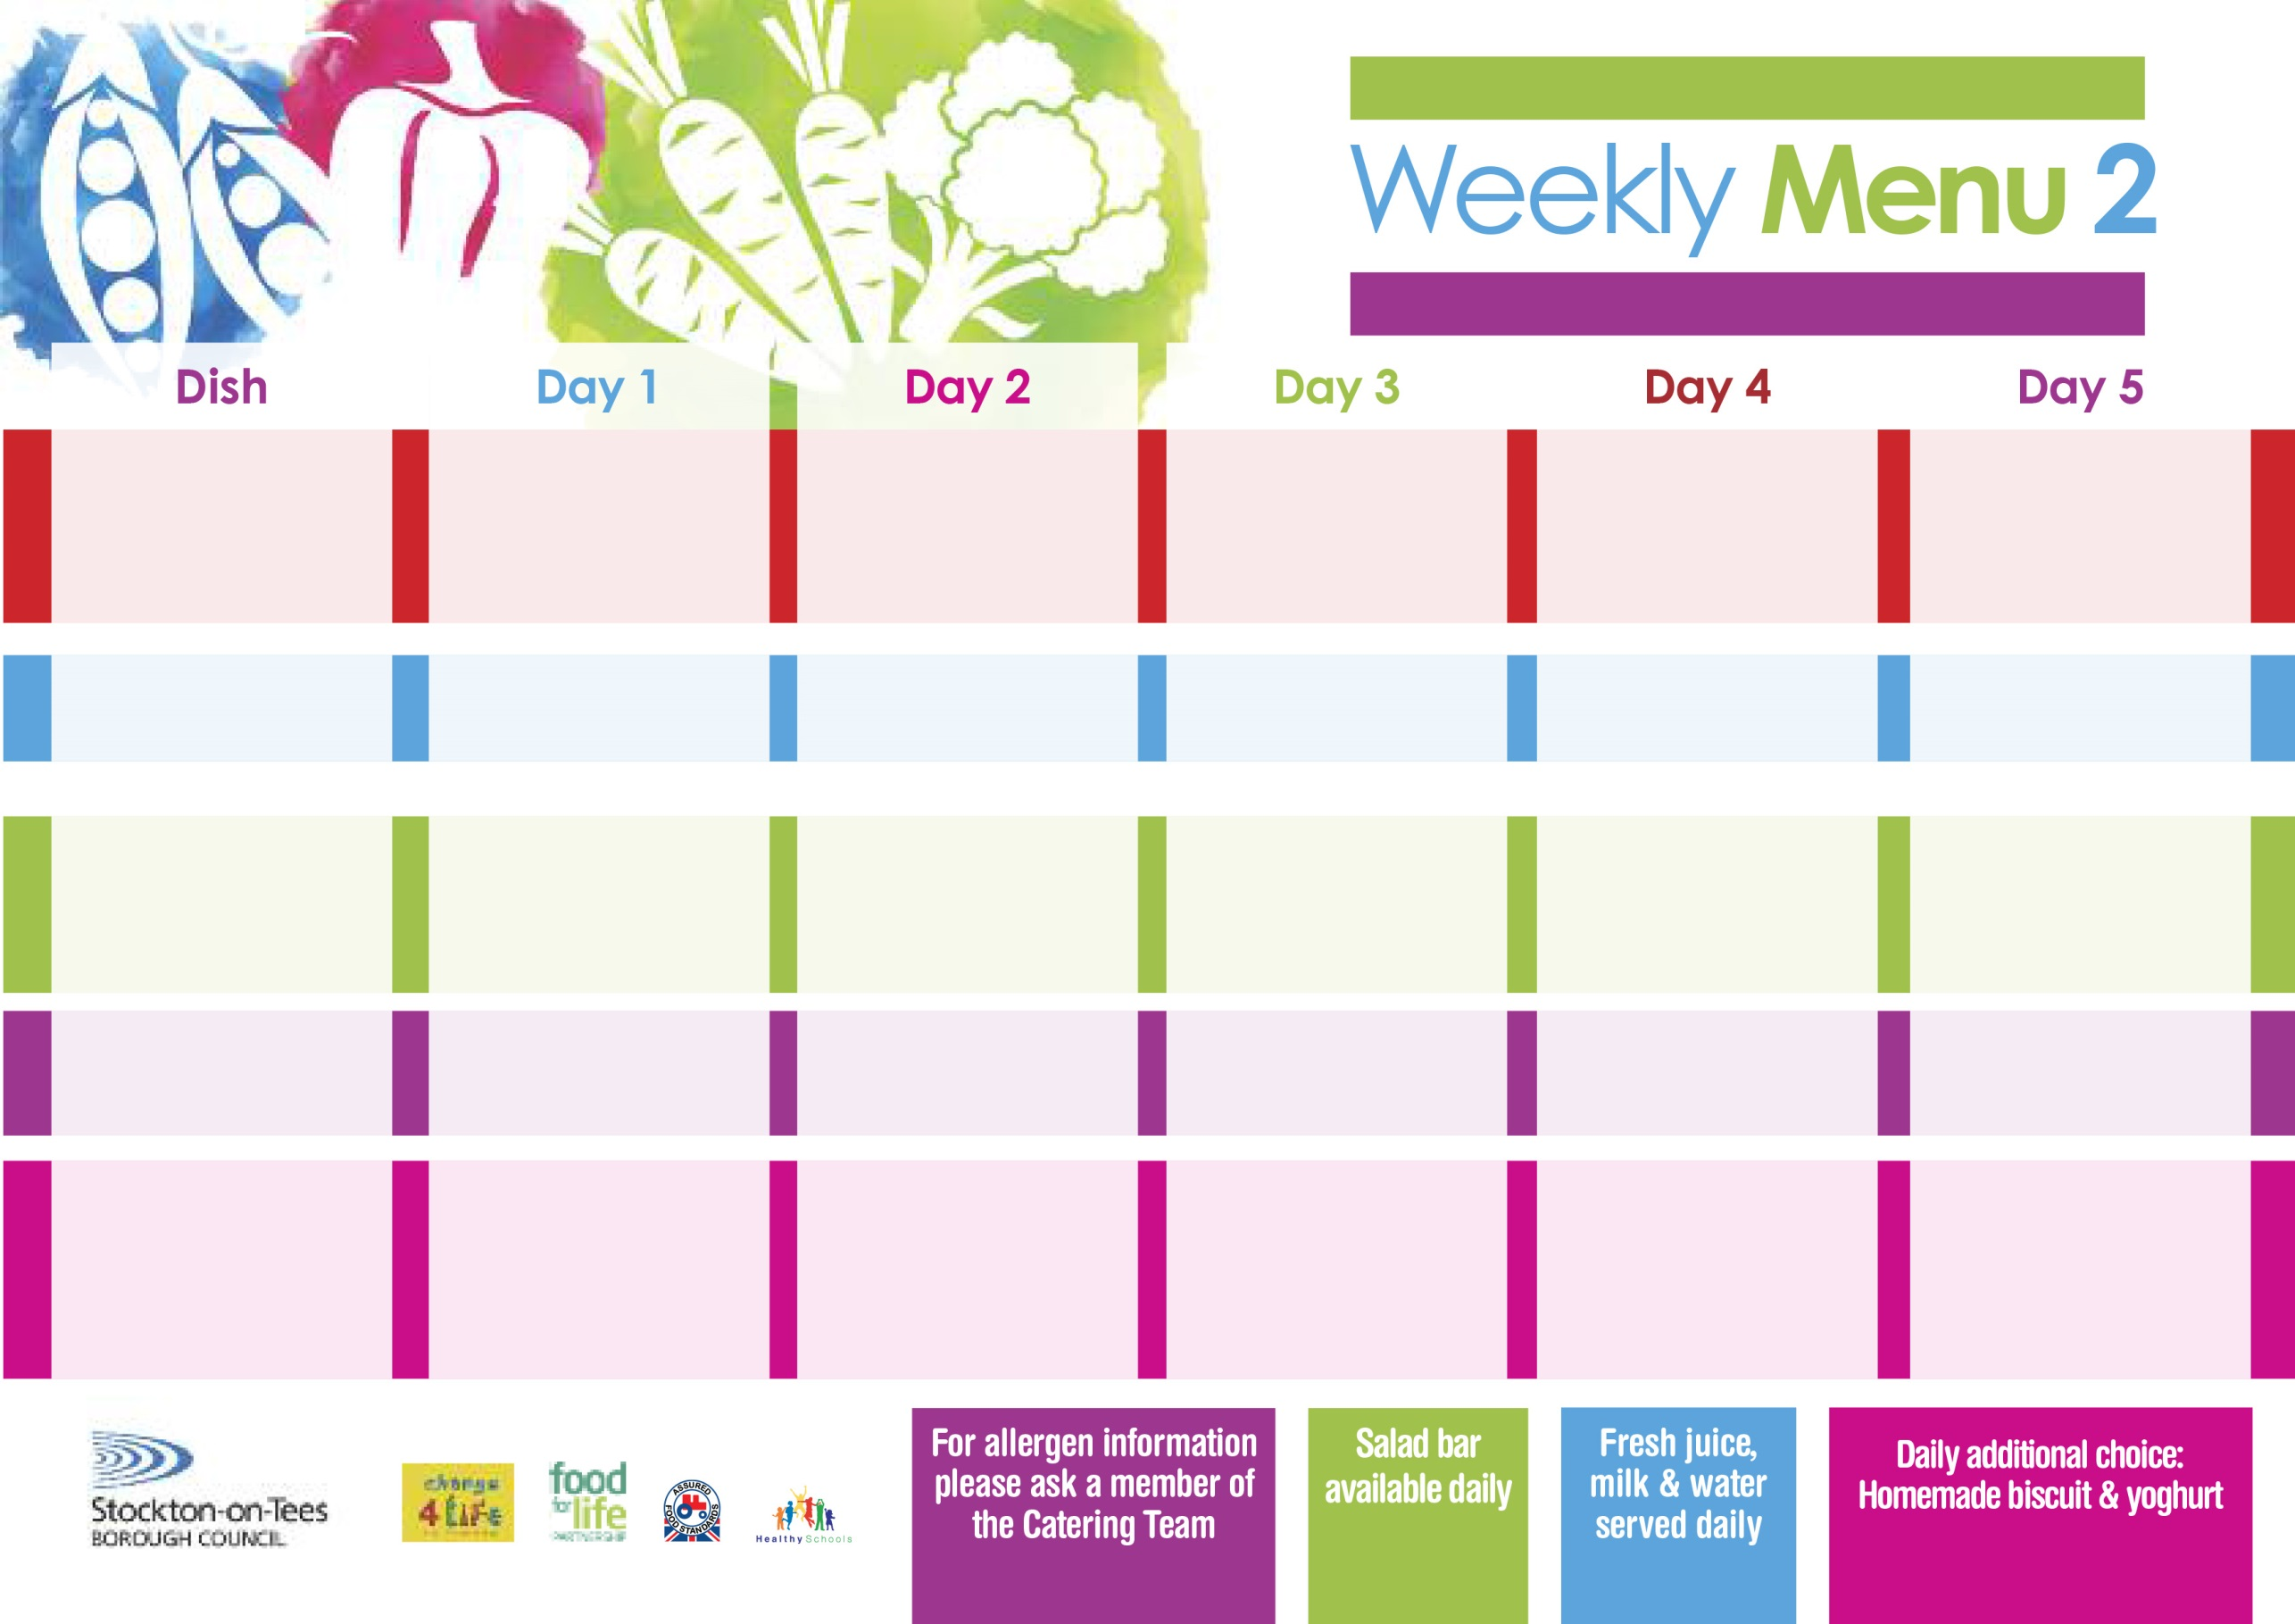

**Spaghetti Bolognaise**

**Homemade Garlic Bread**

**Garden Peas**

**Sweetcorn**

**Quorn Bolognaise (V)**

**Fish Fillet Fingers**

**Baked Potato Wedges**

**Garden Peas**

**Sweetcorn**

**Egg Mayo Sandwich (V)**

**Baked Potato Wedges**

**Feathered Sponge**

**with Custard Sauce**

**Cold Bar**

**Fresh Fruit Bowl**

**24th April, 22nd May & 26th June, 2023**

**Beef Burger in a Bun**

**Oven Roasted Potatoes**

**Baked Beans**

**Quorn Burger in a Bun (V)**

**Macaroni Cheese (V)**

**Homemade Herby Bread**

**Mixed Vegetables**

**Ham Sandwich**

**Oven Roasted Potatoes**

**Cornflake Tart**

**with Custard Sauce**

**Cold Bar**

**Fresh Fruit Salad**

**Toad In The Hole**

**Baby Boiled Potatoes**

**Cauliflower**

**Cabbage**

**Quorn Sausages with Yorkshire Pudding (V)**

**Mini Baked Cheese Slice (V)**

**Baby Boiled Potatoes**

**Spaghetti Hoops**

**Cheese Sandwich (V)**

**Baby Boiled Potatoes**

**Creamy Rice Pudding**

**with Jam Sauce**

**Cold Bar**

**Fresh Fruit Bowl**

**Fish Goujons**

**Oven Baked Chips**

**Garden Peas**

**Baked Beans**

**Homemade Pizza (V)**

**Oven Baked Chips**

**Garden Peas**

**Baked Beans**

**Egg Mayo Sandwich (V)**

**Oven Baked Chips**

**Jam Sponge**

**with Custard Sauce**

**Cold Bar**

**Fresh Fruit Bowl**

**Chicken Pie**

**Creamed Potatoes**

**Broccoli**

**Diced Carrots**

**Jacket Potato Filled with**

**Tuna, Cheese (V)**

**or Baked Beans (V)**

**Tuna Sandwich**

**Baked Jacket Potato**

**Chocolate Crunch**

**with Custard Sauce**

**Cold Bar**

**Fresh Fruit Salad**

**Wristband Primary School Menu**

**Red Choice**

**Blue Choice**

**Green Choice**

**Cold Selection**

**Desserts**