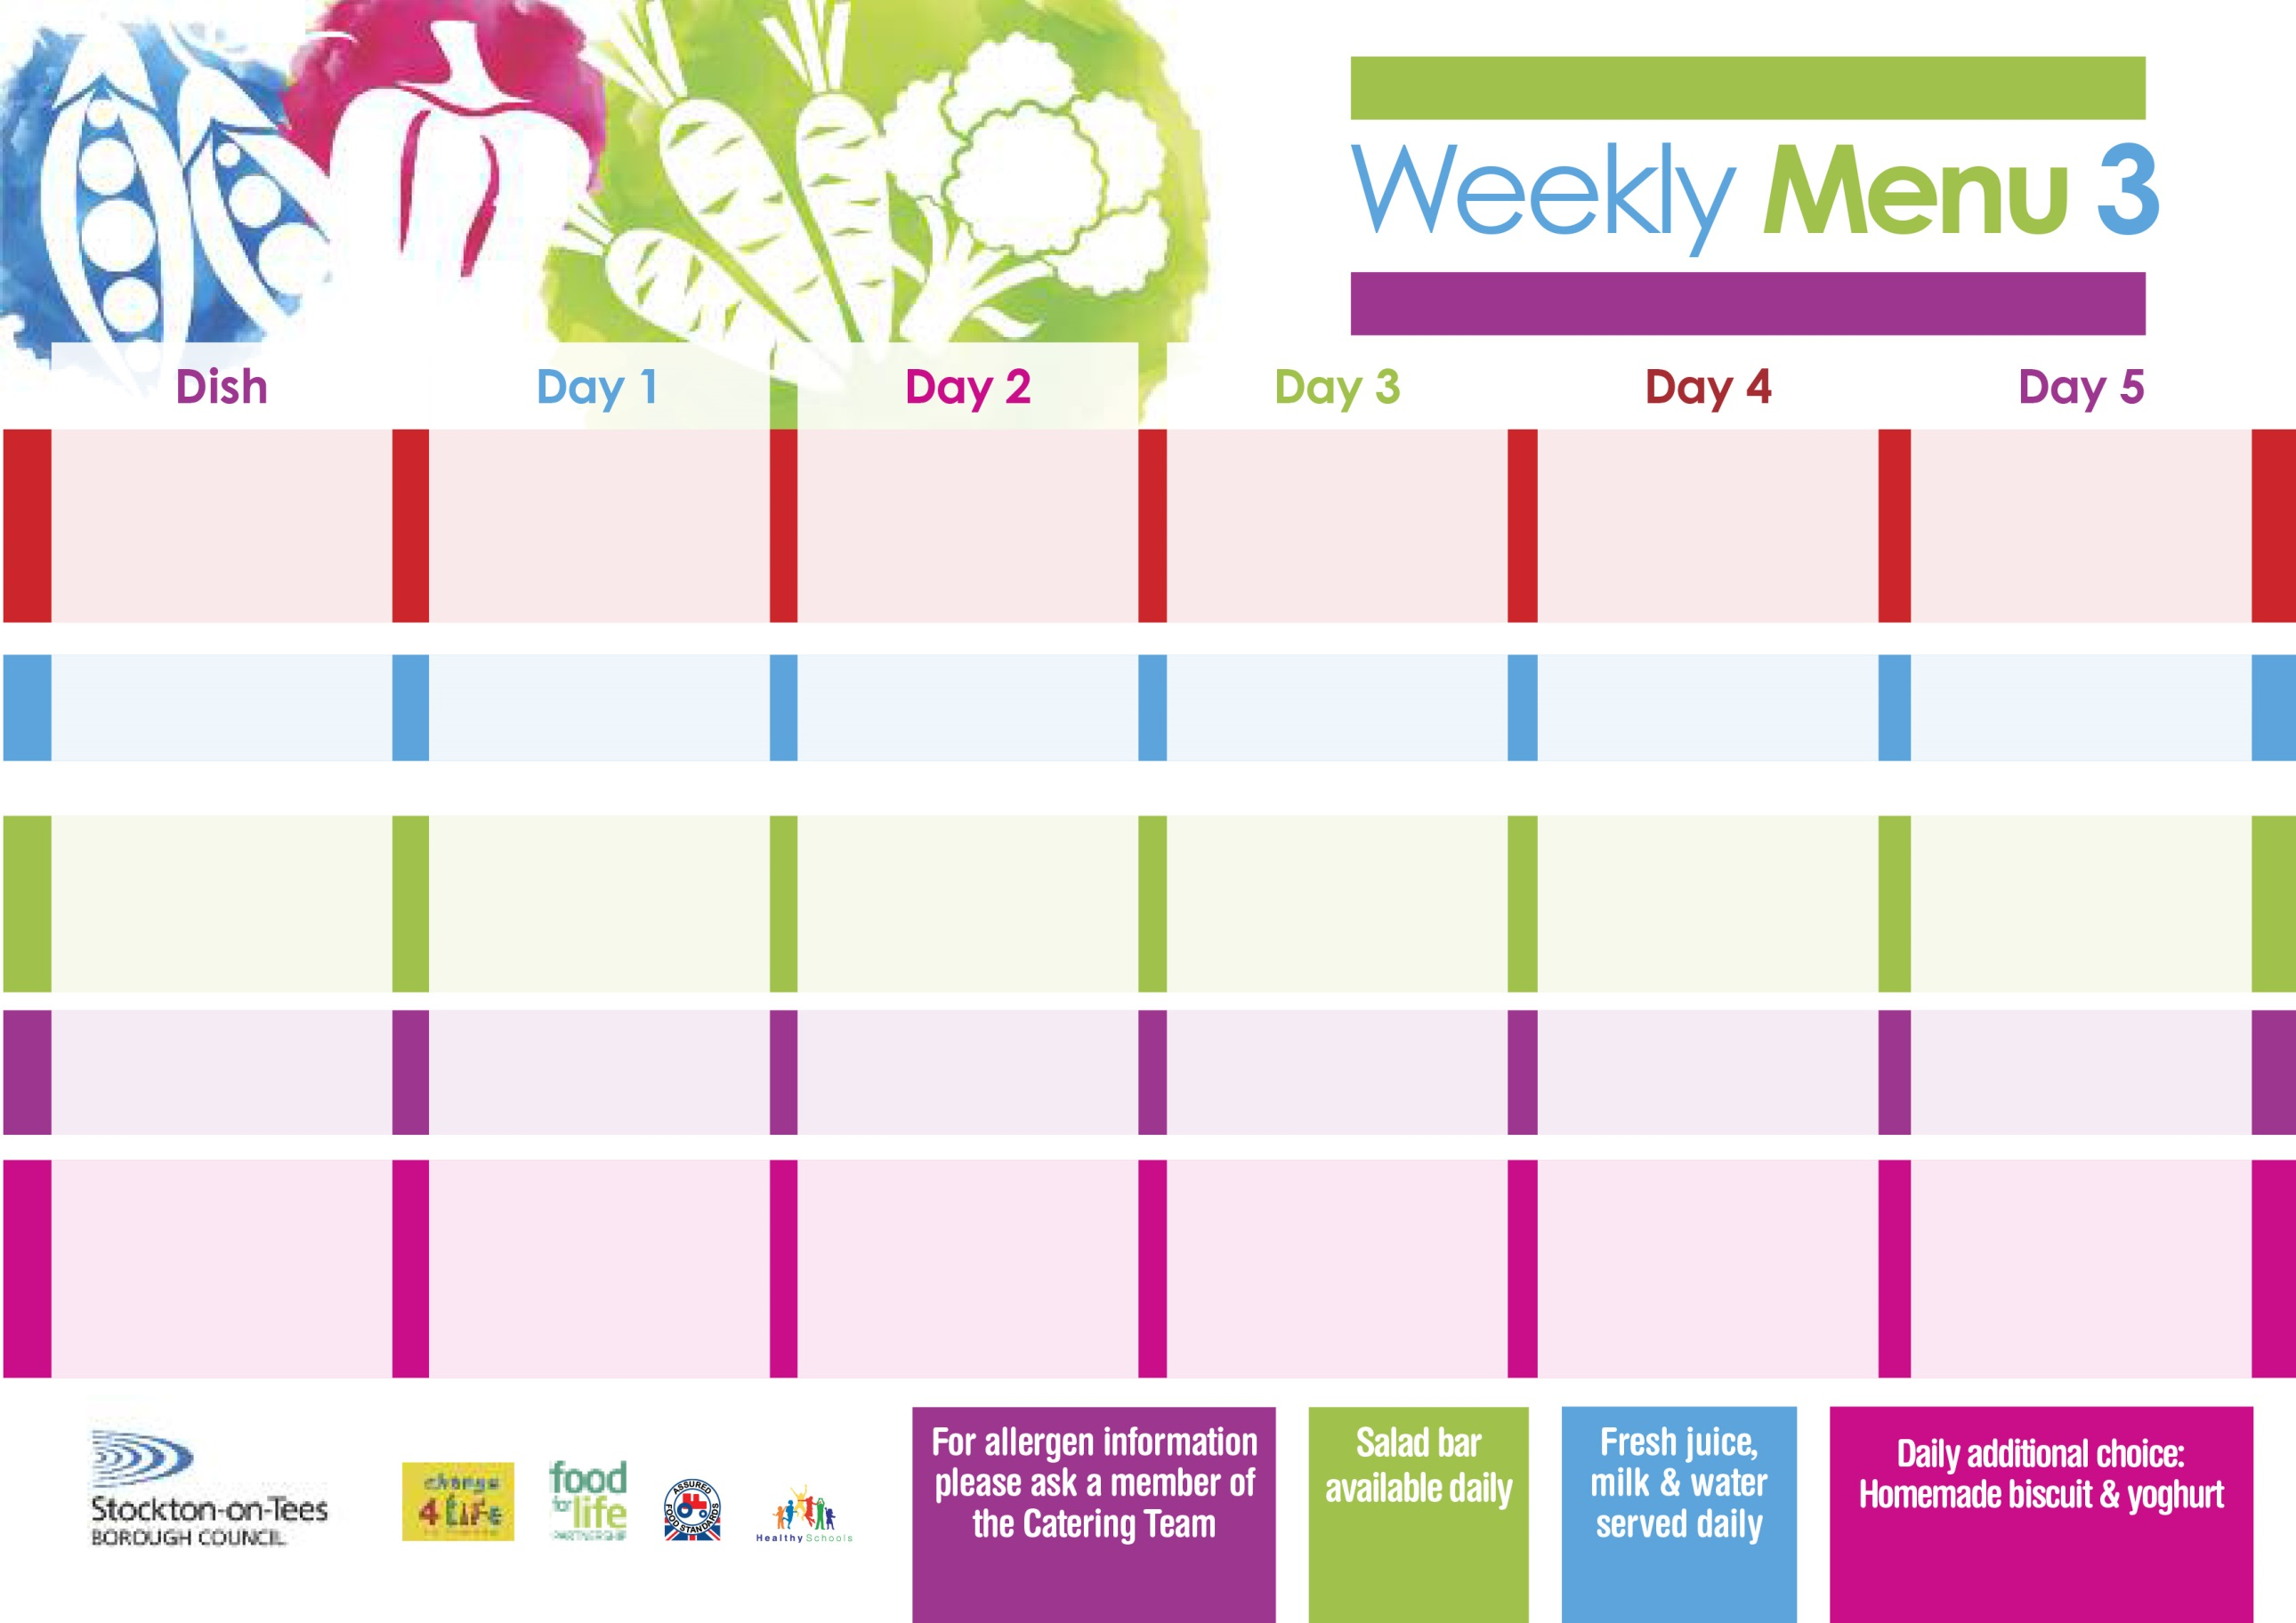

**Lasagne**

**Homemade Garlic Bread**

**Tossed Salad**

**Coleslaw**

**Quorn Lasagne (V)**

**Jacket Potato filled with**

**Tuna, Cheese (V)**

**or Baked Beans (V)**

**Egg Sandwich (V)**

**Baked Jacket Potatoes**

**Ginger Sponge**

**with Custard Sauce**

**Cold Bar**

**Fresh Fruit Salad**

**1st May, 5th June & 3rd July, 2023**

**Salmon & Sweet Potato Fishcake**

**Oven Baked Chips**

**Garden Peas**

**Baked Beans**

**Pizza** **(V)**

**Oven Baked Chips**

**Garden Peas**

**Baked Beans**

**Egg Mayo Sandwich (V)**

**Oven Baked Chips**

**Creamy Rice Pudding**

**with Jam Sauce**

**Cold Bar**

**Fresh Fruit Bowl**

**Chicken Casserole & Dumplings**

**Creamed Potatoes**

**Green Beans**

**Cauliflower**

**Quorn Sausage in a Bun**

**(V)**

**Sausage in a Bun**

**Baked Potato wedges**

**Spaghetti Hoops**

**Cheese Sandwich (V)**

**Baked Potato Wedges**

**Eve’s Pudding**

**with Custard Sauce**

**Cold Bar**

**Fresh Fruit Bowl**

**Roast Gammon & Pineapple**

**Oven Roasted Potatoes**

**Broccoli**

**Diced Carrots**

**Cheese Omelette (V)**

**Oven Roasted Potatoes**

**Broccoli**

**Diced Carrots**

**Tuna Sandwich**

**Oven Roasted Potatoes**

**Jam Roly Poly**

**with Custard Sauce**

**Cold Bar**

**Fresh Fruit Salad**

**Minced Beef Pie**

**Creamed Potatoes**

**Mixed Vegetables**

**Diced Carrots**

**Penne Pasta in a Tomato Sauce (V)**

**Homemade Cheese Bread**

**Mixed Vegetables**

**Tuna Sandwich**

**Baked Jacket Potato**

**Chocolate Chip Sponge**

**with Custard Sauce**

**Cold Bar**

**Fresh Fruit Bowl**

**Red Choice**

**Blue Choice**

**Green Choice**

**Cold Selection**

**Desserts**

**Wristband Primary School Menu**