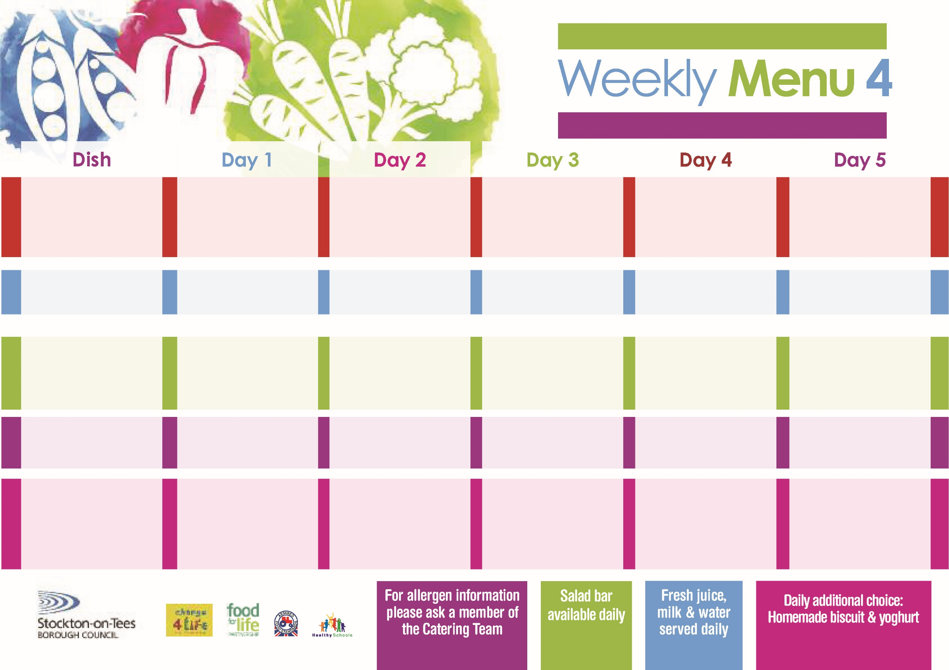

**8th May, 12th June & 10th July, 2023**

**Fish Goujons**

**Oven Baked Chips**

**Garden Peas**

**Baked Beans**

**Baked Cheese & Onion Roll**

**(V)**

**Sausage Roll**

**Oven Baked Chips**

**Garden Peas**

**Baked Beans**

**Cheese Sandwich (V)**

**Oven Baked Chips**

**Chocolate Lime Sponge**

**with Custard Sauce**

**Cold Bar**

**Fresh Fruit Bowl**

**Chicken Curry with Rice**

**Cauliflower**

**Sweetcorn**

**Jacket Potato filled with**

**Tuna, Cheese (V)**

**or Baked Beans (V)**

**Egg Mayonnaise Sandwich**

**(V)**

**Baked Jacket Potatoes**

**Creamy Rice Pudding**

**with Jam Sauce**

**Cold Bar**

**Fresh Fruit Salad**

**Meatballs in Tomato Sauce**

**served with Pasta**

**Green Beans**

**Mixed Vegetables**

**Quorn Meatballs**

**in Tomato Sauce (V)**

**Fishcake**

**Baked Jacket Potato**

**Spaghetti Hoops**

**Cheese Sandwich** **(V)**

**Oven Roasted Potatoes**

**Marble Sponge**

**with Custard Sauce**

**Cold Bar**

**Fresh Fruit Bowl**

**Corned Beef Pie**

**Oven Roasted Potatoes**

**Garden Peas**

**Baked Beans**

**Pizza (V)**

**Oven Roasted Potatoes**

**Garden Peas**

**Baked Beans**

**Tuna Sandwich**

**Baked Jacket Potatoes**

**Oaty Apple Crumble**

**with Custard Sauce**

**Cold Bar**

**Fresh Fruit Salad**

**Mediterranean Bolognaise**

**with Pasta Twirls**

**Homemade Garlic Bread**

**Broccoli**

**Sweetcorn**

**Mediterranean**

**Quorn Bolognaise**

**with Pasta Twirls (V)**

**Homemade Cheese Quiche (V)**

**Baked Potato Wedges**

**Broccoli & Sweetcorn**

**Ham Sandwich**

**Baked Potato Wedges**

**Syrup Sponge**

**with Custard Sauce**

**Cold Bar**

**Fresh Fruit Bowl**

**Red Choice**

**Blue Choice**

**Green Choice**

**Cold Selection**

**Desserts**

**Wristband Primary School Menu**