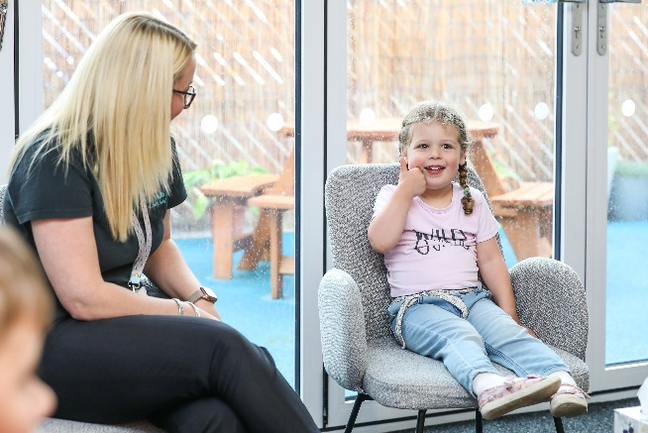
Midwifery service To contact your community midwife, call 01642 615415.
Antenatal Nurturing 5 week programme supports in preparing practically, physically and emotionally for the upcoming birth of your baby.
Parentcraft 4 week programme to help prepare for your new baby. Course delivered by Midwives and Health Visitors. Call 01642 383440 to book.
Practical Parenting a 2 week programme of practical support and preparation you need ready for the arrival of your baby including bathing, sterilising and safe sleep.
Welcome to the Family Hubs: a one off online session to see how Family Hubs can support you on your parenting journey.

Expectant Parents
Your guide to Parenting Support



Children’s Wellbeing Workshops

Mindful Together Group sessions that support your children’s mental and emotional health and wellbeing, to help calm their body, mind and build confidence and self-esteem. Suitable for ages 5 - 11 years.
Chill Skills/Create Designed to help young people aged 11+ to feel more confident, improve their learning potential and manage their emotions.


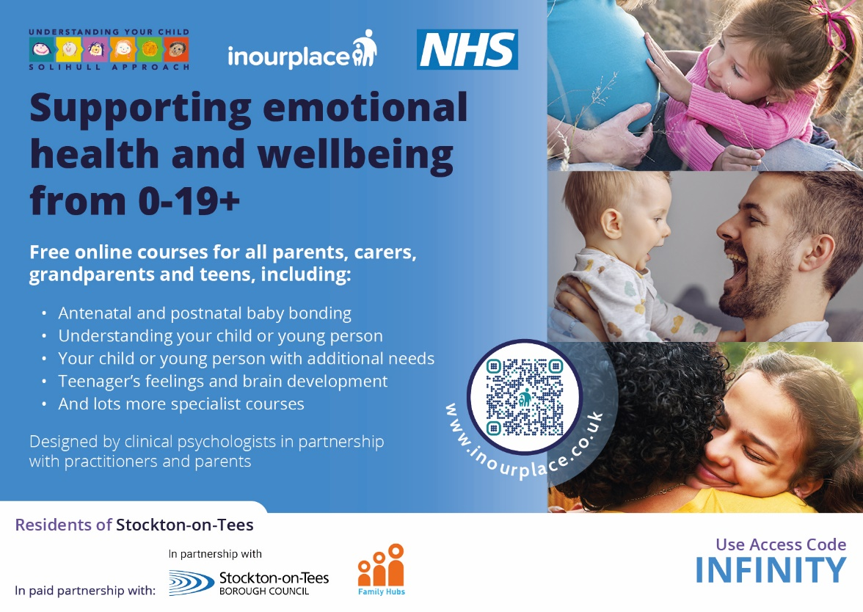

Billingham, Redhill, Stockton and Thornaby Family Hubs

Follow us on Facebook for the latest news and activities:
www.facebook.com/SOTfamilyhubs
01642 528525




Scan to find your local Family Hub

Parent Workshops and Courses
Sleep, Behaviour and Toilet Training Support Contact us for individual appointments either face to face or via the telephone.
Tots Talking 4 or 8 week programme for parents of 2 year olds concerned about speech delays.
Henry 8 week programme for parents with children under the age of 5. This programme supports you in feeling more confident as a parent, reducing mealtime stress, being more active as a family and encouraging your child away from screens.

Nurturing 10 week parenting programme to help parents and carers of children, between 2 and 11 years, to understand and manage feelings and behaviour whilst becoming more positive in their relationships with each other.
Being a Parent An 8-week parent-led programme for families with children aged 2–11, focused on building positive relationships and everyday parenting skills.
EPEC Being a Parent Autism 10 week group for parents of children with Autism aged from 5-12 years. Sessions are led by Parent Group Leaders with lived experience.

Keeping Kids Safe Online Workshop Advice and support in keeping children safe when online and setting appropriate settings and restrictions.
Talking Teens 5 week programme helps to understand a teenager’s brain, improve communication and avoid conflict in the home between parents / carers.

Looking After Ourselves 90 minute workshop supports in recognising the signs of stress in ourselves and what we can do about it as well as ways to recharge our batteries as parents.

Health Visitors For information or advice relating to child health including health, development and baby weighing, call 03333 202302.
Baby Massage 4 week group for babies from 6 weeks old.
Baby Yoga 4 week group for babies from 16 weeks old from EDD.
Family Safety Find out the most common home accidents for children and what we can do to prevent them. Completing this workshop entitles you to access to free and low-cost safety equipment.
Solihull: Understanding Your Baby 6 week group for new parents to attend with their babies (0 - 6 months). Sessions include activities, videos and discussions about baby’s development, communication and more.
Cake and Cuddles 4 week baby group for parents to attend with their babies (6 - 12months) to support and connect with other parents through shared experiences.
New Parents

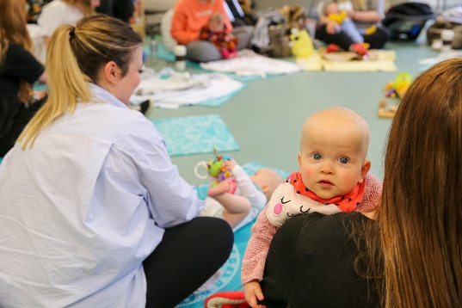
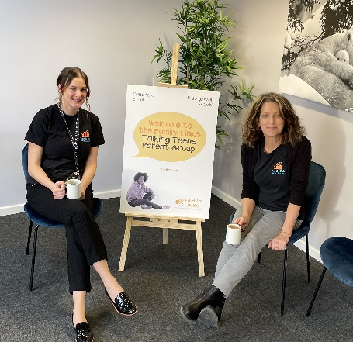

Infant Feeding

Starting Solids Information and guidance on when baby is ready for introducing solid foods. Suitable for babies over 17 weeks.
Tackling Textures Support from the Growing Well Growing Healthy Team. Suitable for babies from 8 months who are struggling to manage textured or lumpier foods.
Dinky Dinners Information and guidance on appropriate portion sizes for your child from the Growing Well Growing Healthy Team. Suitable for babies over 12 months.

