
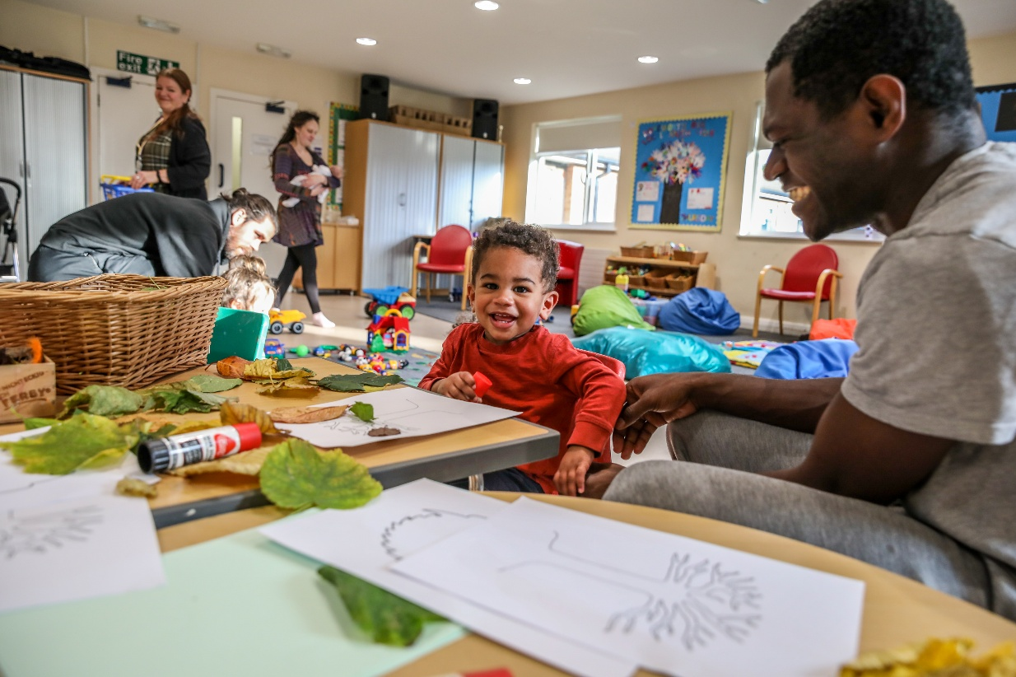

What’s on guide
January
to
April 2026 term time only.
Billingham, Redhill, Stockton and Thornaby, Family Hubs





Billingham Family Hub Stockton Family Hub
Ochil Terrace, Yarm Road
Billingham Stockton
TS23 2QL TS18 3PJ
Redhill Family Hub Thornaby Family Hub
Redhill Road Tedder Avenue
Stockton Thornaby
TS19 9BX TS17 9JP
Follow us on Facebook for the latest news and activities:
www.facebook.com/SOTfamilyhubs
01642 528525




*Call 01642 528525 to book
What’s on at Stockton-on-Tees Family Hubs
Monday | Tuesday | Wednesday | Thursday | Friday
Billingham  Community Garden  10am-12pm  Adults only  Daisy Chain Drop in  10-12pm (from 12th Jan)  Redhill  ** Little Explorers  10-11:30am  SJOG Autism & Mental Health Drop In  1-2.30pm  Perinatal Walk and Talk  1-3pm (fortnightly)  Andy’s Man Club  7pm  Stockton  Perinatal Walk and Talk  10-12pm  Daisy Chain Drop in  10-12pm (from 2nd March)  Thornaby  Babbling Babies  12:30-2pm | Billingham  **Little Explorers  9:30-11am  Harbour Drop-In  10am-12pm  Employment Hub Drop-In  1-3pm (fortnightly)  Redhill  SEND Lego Club  4-5pm  Stockton  Infant Feeding Support  10-11:30am  Warm Welcome  1-3pm  After School Family Fun 3:30-5pm  Thornaby  SEND Peer Support Drop in  Monthly 2nd Week  1-2.30pm  MIND Be Heard  11-13 years 4-5:30pm    14-16 years 5:30-7pm  Scan to book for Be Heard | Billingham  *Messy Play 1st Week  *Soft Play 3rd Week  Monthly 10-11am  Coffee Morning 2nd Week  SEND Coffee Morning 4th Week  Monthly 9:30 – 11am  Redhill  Babbling Babies  9:30-11am  Stockton  ** Little Explorers  10-11:30am  Thornaby  Salvation Project Community Pantry  1.30-2.30pm  Multiples Stay & Play  12.30-2.30pm  **Scan to book Little Explorers | Billingham  Perinatal Walk and Talk  9:30am-11:30am  Infant Feeding Support  1-2pm  After School Family Fun 3:30-5pm  Redhill  *Soft Play 1st Week  Rhyme Time 2nd Week  *Messy Play 3rd Week  Craft & Coffee 4th Week  Monthly 9.30-10.30am  The Bread & Butter Thing  1pm – 1.30pm  Stockton  Sprouts Eco Shop  10am-12pm  Babbling Babies  1-2:30pm  Thornaby  Knit & Natter  9.30 – 11.30am  ** Little Explorers  1-2:30pm | Billingham  Babbling Babies  9:30-11am  Thornaby  “The Lovelies” Friendship Group  1-2:30pm  Stockton  Polish Village Stay and Play  4-5.30pm  Saturday  Billingham  SEND Club  3rd Saturday of the month  10:30am-12pm

